**Subject Code:22CS408PC**

**Course Objectives:**

1. Effective use of Business Intelligence (BI) technology (Tableau) to apply visualization

2. To discern patterns and relationships in the data.

3. To build Dashboard applications.

4. To communicate the results clearly and concisely.

5. To be able to work with different formats of data sets.

**Course Outcomes:** After completion of this course, the students will be able to:

1. Understand How to import data into Tableau.

2. Understand Tableau concepts of Dimensions and Measures.

3. Develop Programs and understand how to map Visual Layouts and Graphical Properties.

4. Create a Dashboard that links multiple visualizations.

5. Use graphical user interfaces to create Frames for providing solutions to real world problems.

**Lab Problems:**

1. Understanding Data, what is data, where to find data, Foundations for building Data Visualizations, and Creating Your First visualization.

2. Getting started with Tableau Software using Data file formats, connecting your Data to Tableau, creating basic charts(line, bar charts, Tree maps), Using the Show me panel.

3. Tableau Calculations, Overview of SUM, AVR, and Aggregate features, Creating custom calculations and fields.

4. Applying new data calculations to your visualizations, Formatting Visualizations, Formatting tools menus, and Formatting specific parts of the view.

5. Editing and Formatting Axes, Manipulating Data in Tableau data, Pivoting Tableau data.

6. Structuring your data, Sorting and filtering Tableau data, and Pivoting Tableau data.

7. Advanced Visualization Tools: Using Filters, Using the Detail panel, using the Size panels, customizing filters, Using and Customizing tooltips, and Formatting your data with colors.

8. Creating Dashboards &amp; Storytelling, creating your first dashboard and Story, Design for different, adding interactivity to your Dashboard, Distributing &amp; Publishing your Visualization.

9. Tableau file types, publishing to Tableau Online, Sharing your visualizations, printing, and Exporting.

10. Creating custom charts, cyclical data and circular area charts, and Dual Axis charts.

## 1. Understanding Data, What is data, where to find data, Foundations for building Data Visualizations, Creating Your First visualization?

## AIM:

# Understanding Data, What is data, where to find data, Foundations for building Data Visualizations,Creating Your First visualization?

## SOLUTION:

# What is Data?

Data refers to raw facts, statistics, or information collected or stored in a structured or unstructured form. Data can take various forms, such as text, numbers, images, videos, and more. It is the foundation of all information and knowledge and is used in various fields for analysis, decision-making, and understanding trends and patterns.

# Data can be categorized into two main types:

* **Structured Data:** This type of data is organized into a specific format, such as tables or databases, and is easily searchable and analyzable. Examples include spreadsheets, relational databases, and CSV files.
* **Unstructured Data:** Unstructured data lacks a specific format and can include text documents, social media posts, images, audio recordings, and more. Analyzing unstructured data often requires advanced techniques like natural language processing and image recognition.

# Where to Find Data?

You can find data from various sources, depending on your specific needs:

* **Open Data Portals:** Many governments and organizations provide free access to a wide range of data through open data portals. Examples include Data.gov (United States) and data.gov.uk (United Kingdom).
* **Data Repositories:** Academic institutions, research organizations, and data enthusiasts often share datasets on platforms like Kaggle, GitHub, and the UCI Machine Learning Repository.
* **APIs (Application Programming Interfaces):** Some websites and services offer APIs that allow you to programmatically access and retrieve data. Examples include Twitter API, Google Maps API, and financial market APIs.
* **Web Scraping:** You can extract data from websites using web scraping tools and libraries like BeautifulSoup and Scrapy. However, be mindful of the website's terms of use and legal restrictions.
* **Surveys and Surveys:** You can conduct your own surveys or collect data through questionnaires and interviews.
* **IoT Devices:** Internet of Things (IoT) devices generate vast amounts of data that can be used for various purposes.
* **Commercial Data Providers:** Some companies specialize in selling datasets for specific industries, such as market research, finance, and healthcare.

# Foundations for Building Data Visualizations:

Creating effective data visualizations requires a strong foundation in several key areas:

* **Data Analysis:** Before creating visualizations, you should thoroughly analyze your data to understand its structure, relationships, and any patterns or trends. Exploratory data analysis (EDA) techniques can help with this.
* **Statistical Knowledge:** Understanding basic statistics is essential for making meaningful interpretations of data. Concepts like mean, median, standard deviation, and correlation are commonly used in data visualization.
* **Domain Knowledge:** Having knowledge of the specific domain or subject matter related to your data is crucial for creating contextually relevant visualizations. It helps you ask the right questions and provide valuable insights.
* **Visualization Tools:** Familiarize yourself with data visualization tools and libraries such as matplotlib, Seaborn, ggplot2, D3.js, and Tableau. Each tool has its strengths and can be used for different types of visualizations.
* **Design Principles:** Study design principles, including color theory, typography, and visual hierarchy, to create visually appealing and effective visualizations. Avoid common pitfalls like misleading visualizations.
* **Interactivity:** Learn how to add interactive elements to your visualizations to engage users and allow them to explore the data. This can be achieved using tools like JavaScript, Python libraries, or dedicated visualization software.

# Creating Your First Visualization:

To create your first data visualization, follow these general steps:

* **Select Your Data:** Choose a dataset that aligns with your goals and interests. Ensure that the data is clean and well-structured.
* **Define Your Objective:** Clearly define what you want to communicate or explore with your visualization. Are you looking to show trends, comparisons, or distributions?
* **Choose the Right Visualization Type:** Select a visualization type that suits your data and objectives. Common types include bar charts, line charts, scatter plots, histograms, and pie charts.
* **Prepare and Transform Data:** Preprocess your data as needed. This may involve aggregating, filtering, or transforming the data to fit the chosen visualization.
* **Create the Visualization:** Use a suitable tool or library to create your visualization. Customize it with labels, colors, and other design elements.
* **Interactivity (Optional):** If appropriate, add interactive features to your visualization to allow users to interact with the data.
* **Test and Iterate:** Review your visualization for accuracy and clarity. Seek feedback from others and make improvements as necessary.
* **Publish or Share:** Once you are satisfied with your visualization, publish it on a platform, embed it in a report, or share it with your intended audience.
* **Document and Explain:** Provide context and explanations for your visualization. Clearly communicate what the viewer should take away from it.
* **Maintain and Update:** If the data changes or new insights emerge, update your visualization accordingly.

# 2. Getting started with Tableau Software using Data file formats, connecting your Data to Tableau,creating basic charts(line, bar charts, Tree maps),Using the Show me panel.

## Aim:

# Getting started with Tableau Software using Data file formats, connecting your Data to Tableau,creating basic charts(line, bar charts, Tree maps),Using the Show me panel.

## Solution :

Getting started with Tableau software is a great way to create data visualizations quickly and efficiently. Here are the steps to get started, including connecting your data to Tableau, creating basic charts like line charts, bar charts, and treemaps, and using the Show Me panel:

# 1. Download and Install Tableau:

First, you'll need to download and install **Tableau Desktop** or **Tableau Public** (a free version). Follow the installation instructions provided on the Tableau website for your specific operating system.

# 2. Prepare Your Data:

Before connecting your data to Tableau, ensure that your data is in a suitable format. Common data file formats that Tableau supports include **Excel (.xlsx), CSV (.csv), and text files (.txt)**. Make sure your data is organized with headers for each column.

# 3. Connect Your Data to Tableau:

3.1 Launch **Tableau Desktop.**

3.2 Go to "**File**" Menu and then click on "**Open**".

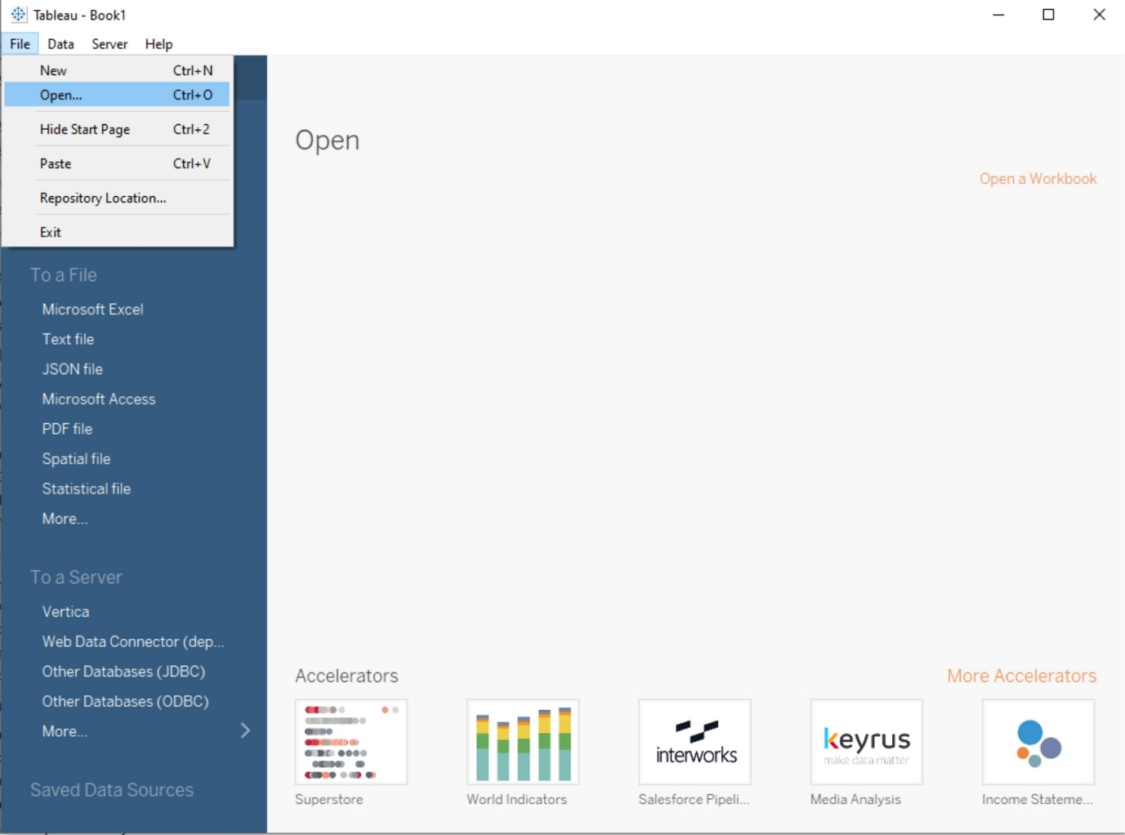  
3.3 Choose the data source type (e.g., Excel, CSV, text file) and Select the data file(**P6-SuperStoreUS-2015.xls**) and click "Open".

3.4 Drag any table(e.g. Orders) into working area.

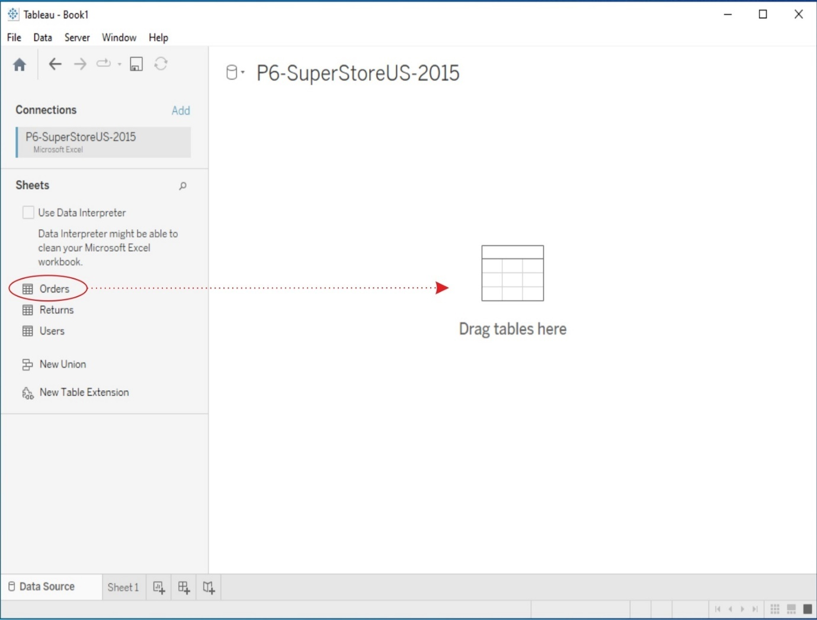

3.5 Click on Worksheet(**Sheet1**)

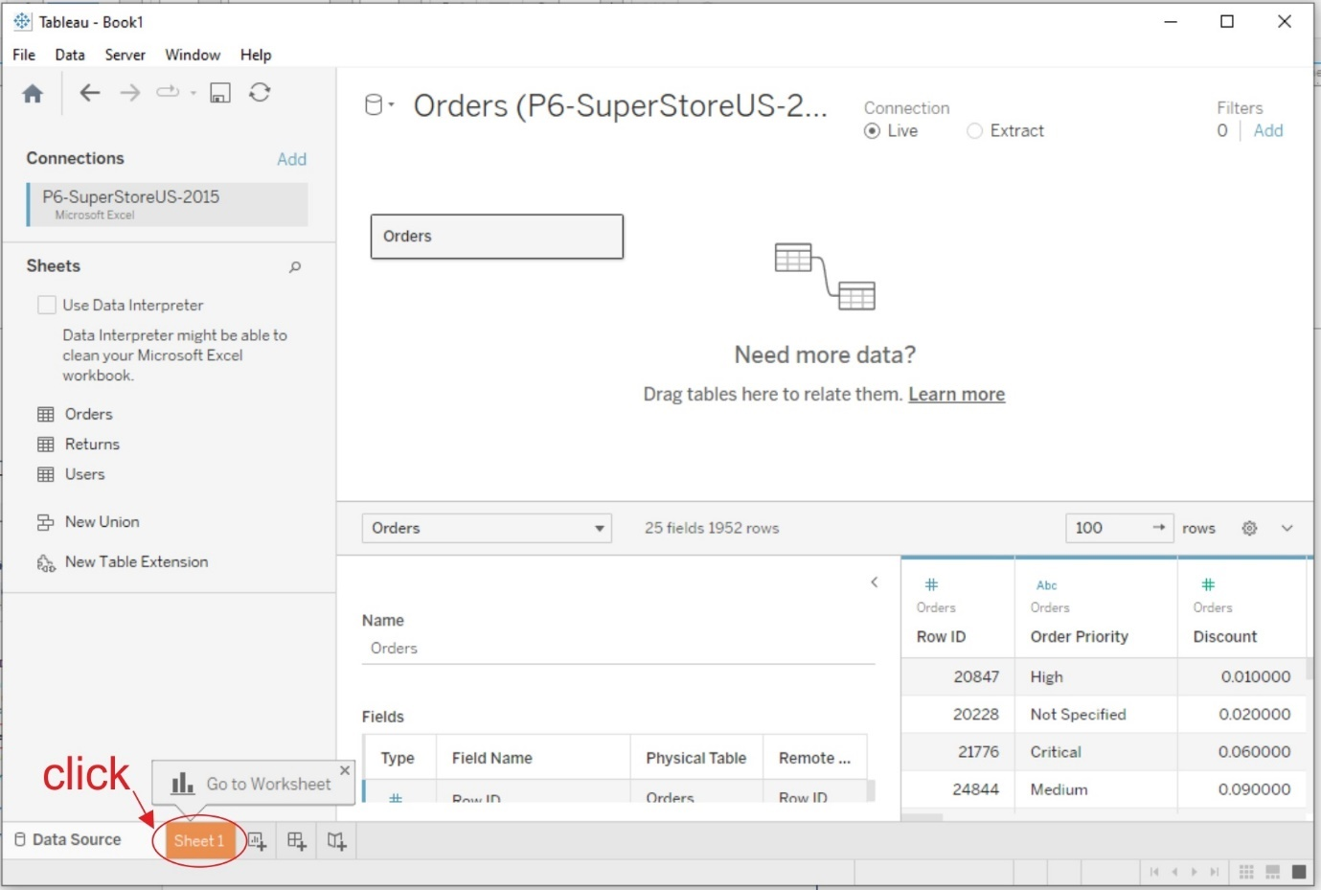

# 4. Data Source Pane:

Once your data is connected, the Data Source Pane will appear on the left-hand side of the Tableau interface. Here, you can see a preview of your data and perform data transformations or join multiple data sources if necessary.

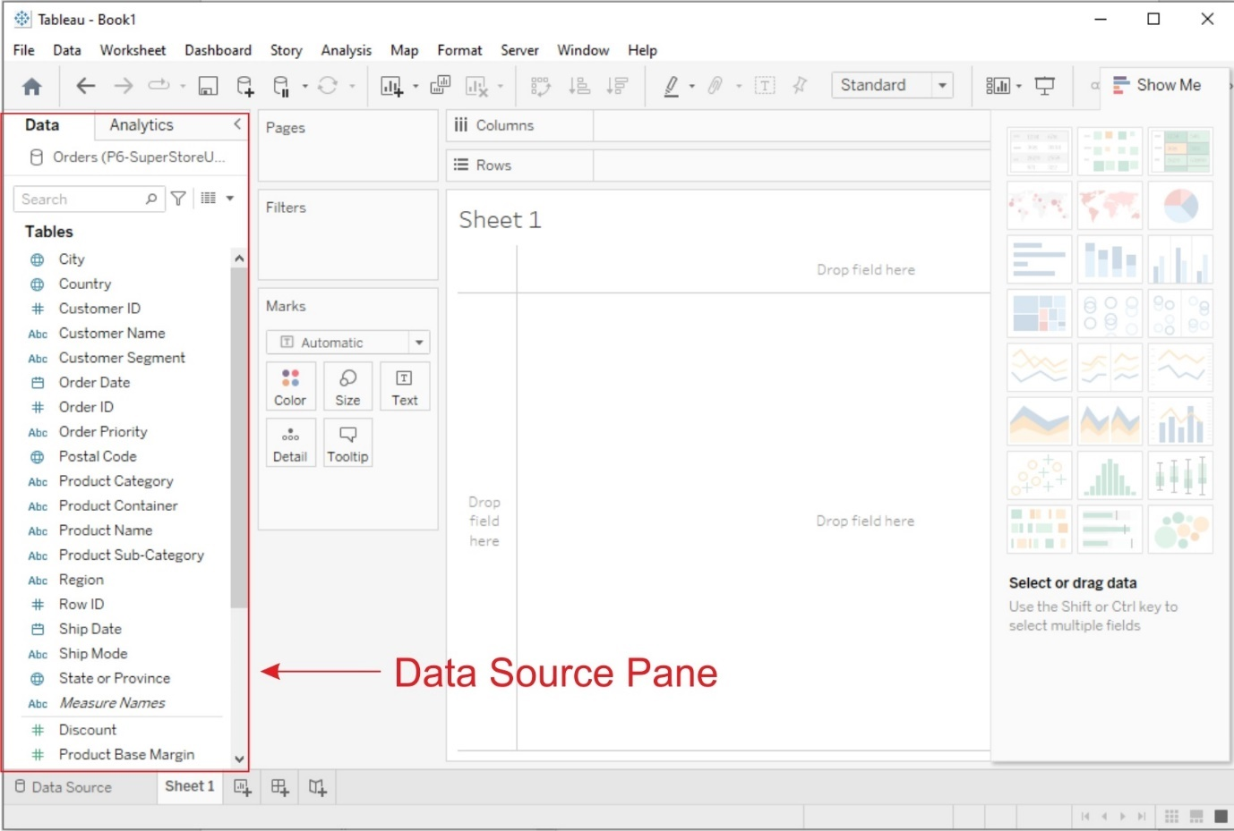

# 5. Creating Basic Charts:

Now, let's create some basic charts using Tableau:

## a. Line Chart:

1. From the "**Data Source pane**", drag and drop the date field to the **Columns shelf** and a numeric field (e.g., sales, revenue) to the **Rows shelf**.

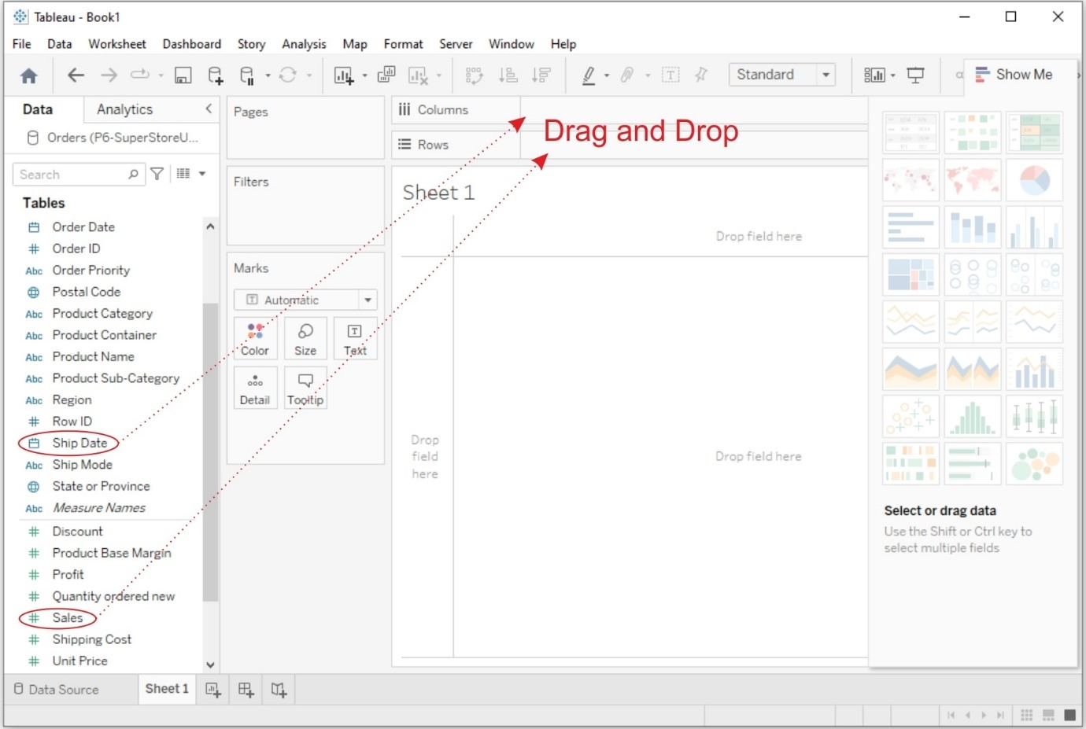

2. Then **Tableau** will automatically create a line chart. You can customize it by adding labels, titles, and formatting.

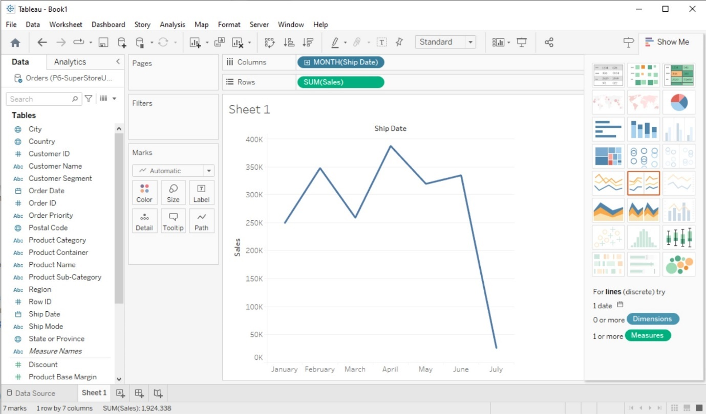

## b. Bar Chart:

1. Drag and drop a **categorical field** (e.g., product category, region) to the Columns shelf and a **numeric field** to the Rows shelf.

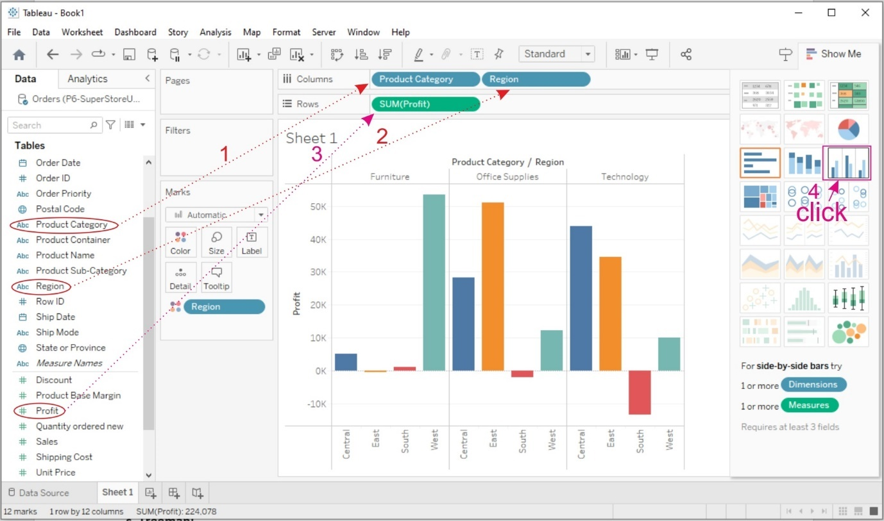

2. Then **Tableau** will create a bar chart. You can adjust the orientation and formatting as needed. To display Labels on the bars click on Lables and select "**Show mark lables**"

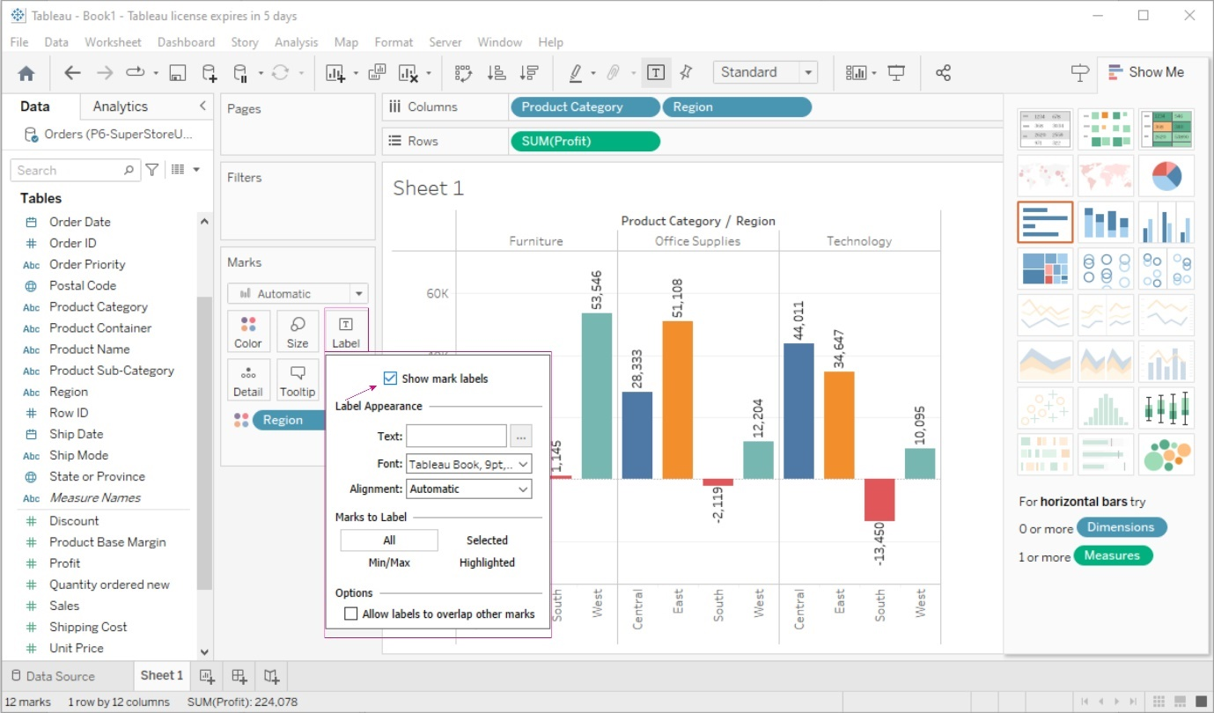

## c. Treemap:

1. Drag and drop a categorical field to the Columns shelf.

2. Drag and drop a numeric field to the Size shelf.

3. Tableau will create a treemap visualization. You can further customize it by adjusting colors and labels.

# 6. Using the Show Me Panel:

The Show Me panel in Tableau helps you explore various chart types based on your data and the fields you select. Here's how to use it:

1. After adding fields to the Rows and Columns shelves, click on the "Show Me" panel located on the left side of the Tableau interface.

2. In the Show Me panel, you'll see a variety of chart options that Tableau recommends based on your data. Click on a chart type to create it.

3. Tableau will automatically generate the selected chart type with your data. You can further customize it as needed.

4. To go back to the regular worksheet view, click the "Clear" button in the Show Me panel.

3.Tableau Calculations, Overview of SUM, AVR, and Aggregate features, Creating custom calculationsand fields

## AIM:

# Tableau Calculations, Overview of SUM, AVR, and Aggregate features, Creating custom calculationsand fields

## SOLUTION :

Tableau offers a powerful set of calculation tools that allow you to manipulate, transform, and analyze your data in various ways. Here's an overview of some key concepts related to Tableau calculations, including SUM, AVG (average), and aggregate functions, as well as creating custom calculations and fields

# SUM and AVG (Average) Functions

## SUM Function

The SUM function in Tableau calculates the total sum of a numeric field. You can use it to find the sum of values in a column or as part of a more complex calculation. To use SUM, simply drag and drop a numeric field into the "SUM" shelf, or you can create a calculated field using the SUM function.

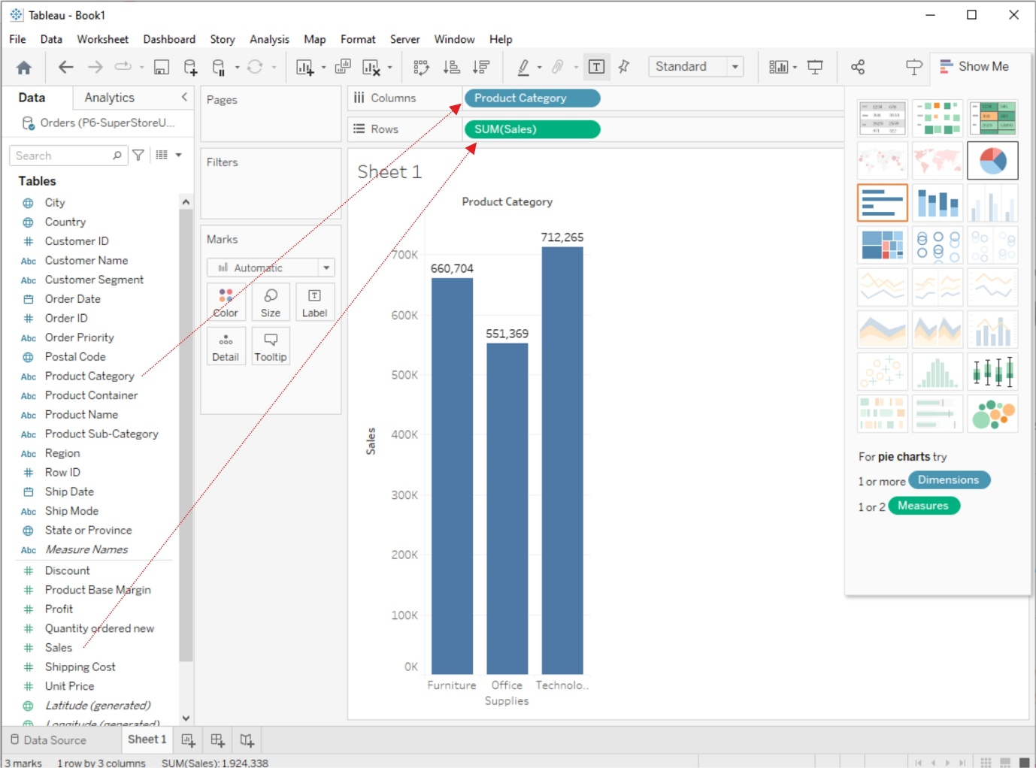

## AVG (Average) Function

The AVG function calculates the average (mean) value of a numeric field. Like SUM, you can use it by dragging a numeric field into the "AVG" shelf or creating a calculated field with the AVG function.

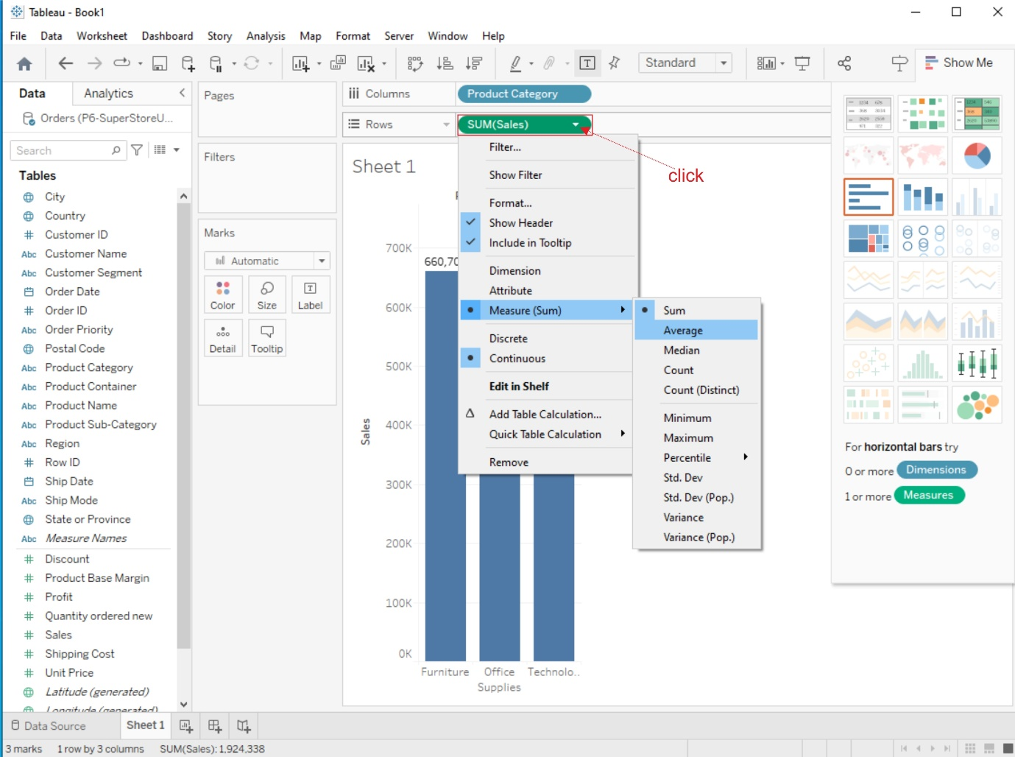

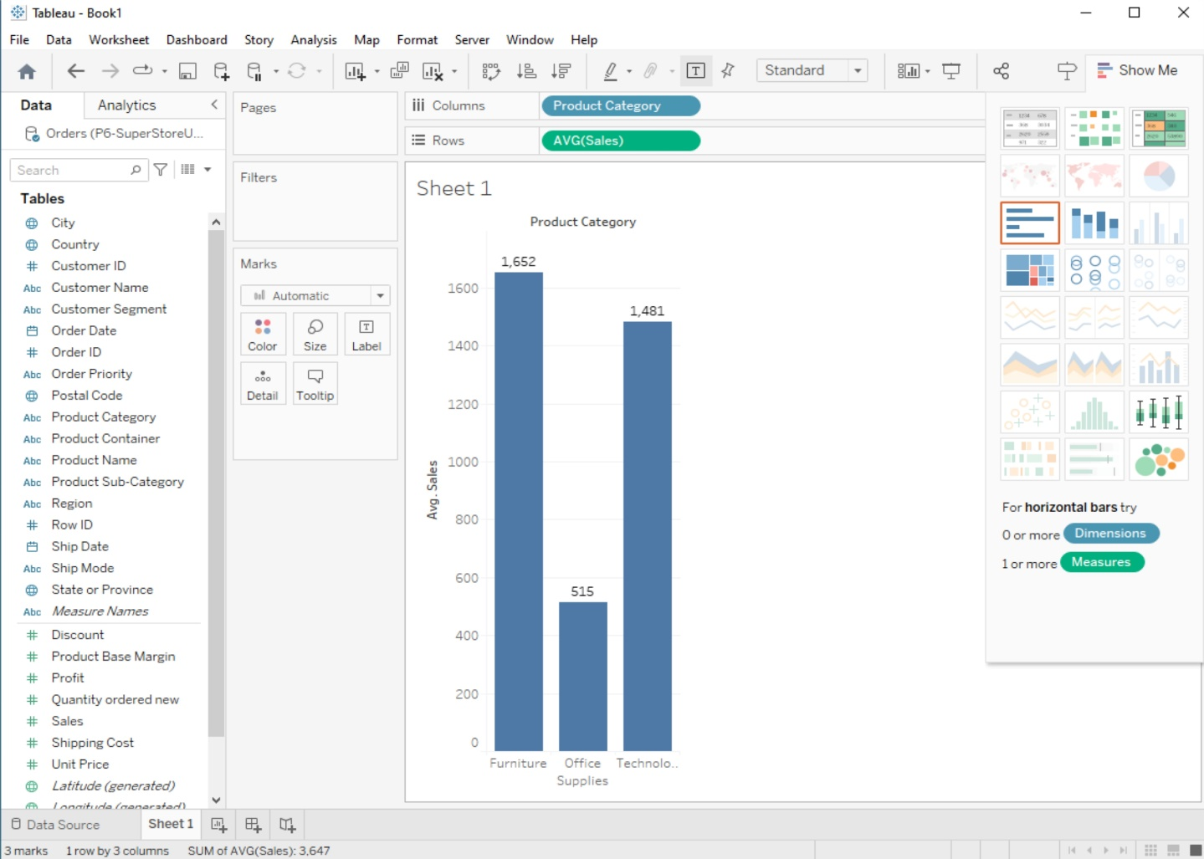

# Aggregate Functions:

Tableau provides a range of aggregate functions that allow you to perform calculations on groups of data. Common aggregate functions include SUM, AVG, COUNT, MIN (minimum value), and MAX (maximum value). These functions are particularly useful when you want to analyze data at different levels of granularity (e.g., by category, region, or time period).

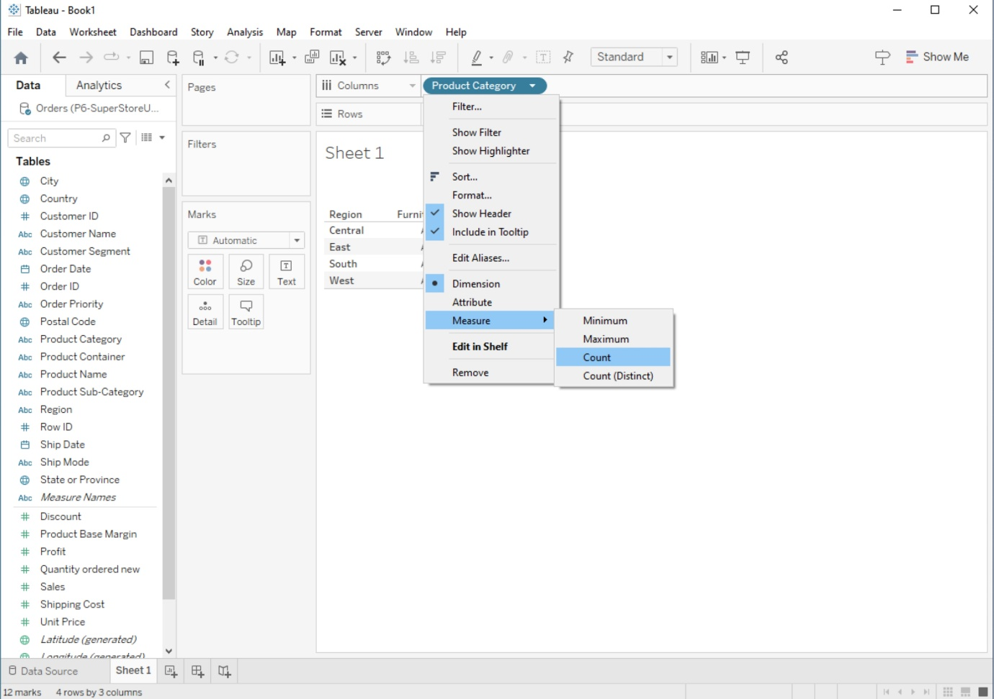

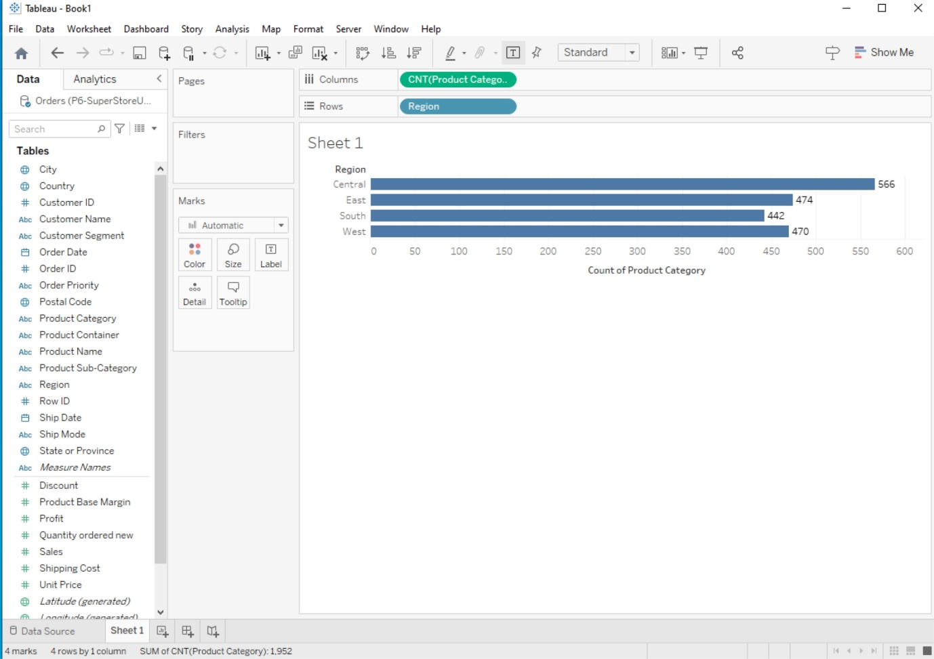

# Creating Custom Calculations

Tableau allows you to create custom calculations using calculated fields. Here's how to create a custom calculation:

## 1. Create a New Calculated Field

In the Data Source Pane, right-click on your data source and select "Create Calculated Field".

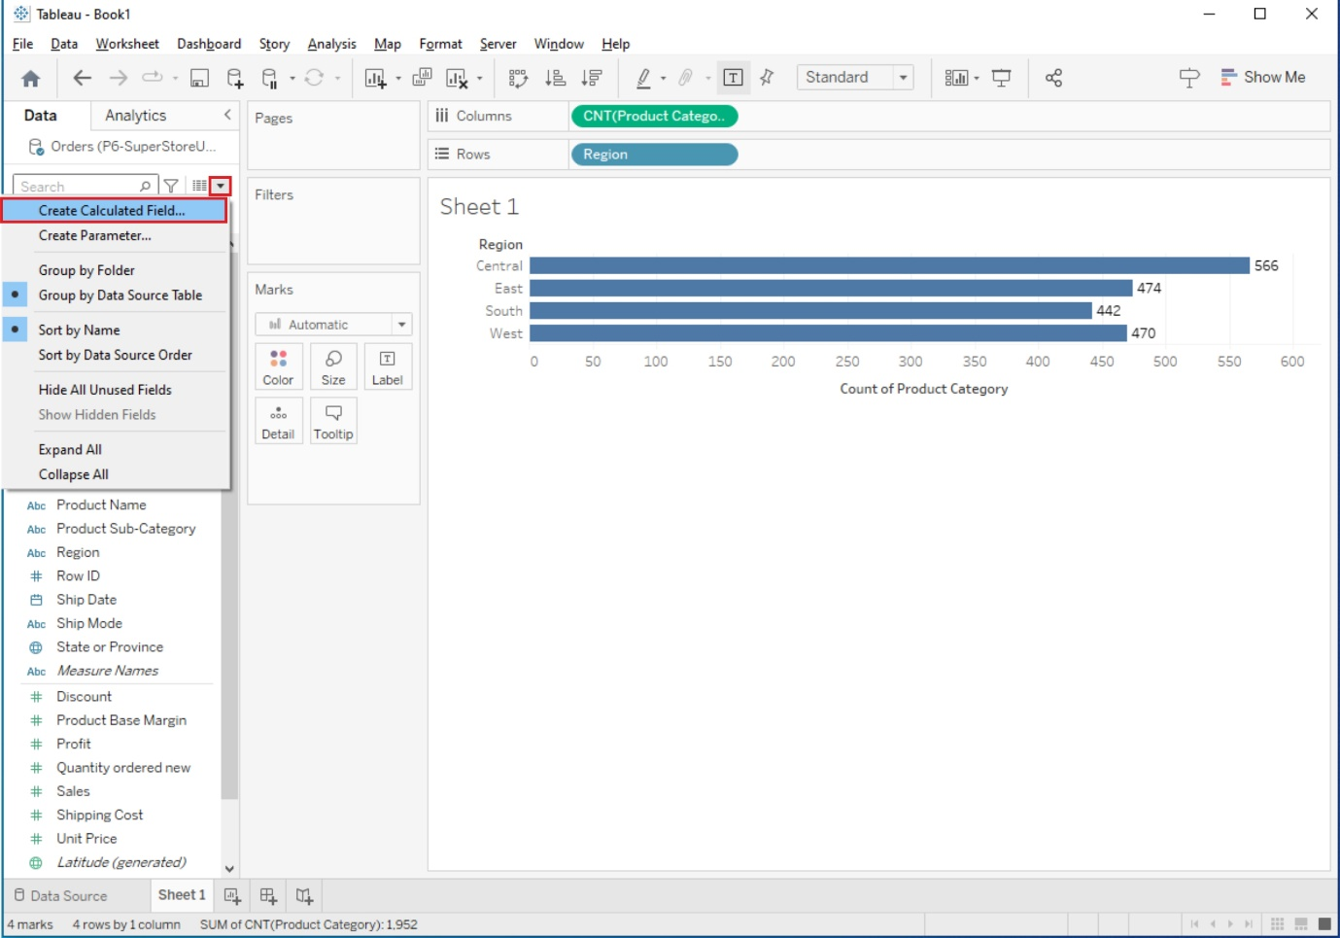

Alternatively, you can create a calculated field by right-clicking on a shelf in your worksheet and choosing "Create Calculated Field".

## 2. Enter Your Calculation:

In the calculated field editor, you can use functions, operators, and field references to define your calculation.

For example, you can create a calculated field to calculate profit margin as (SUM([Profit]) / SUM([Sales])) * 100.

## 3. Name and Save the Calculated Field:

Give your calculated field a meaningful name.

Click the "OK" or "Apply" button to save the calculated field.

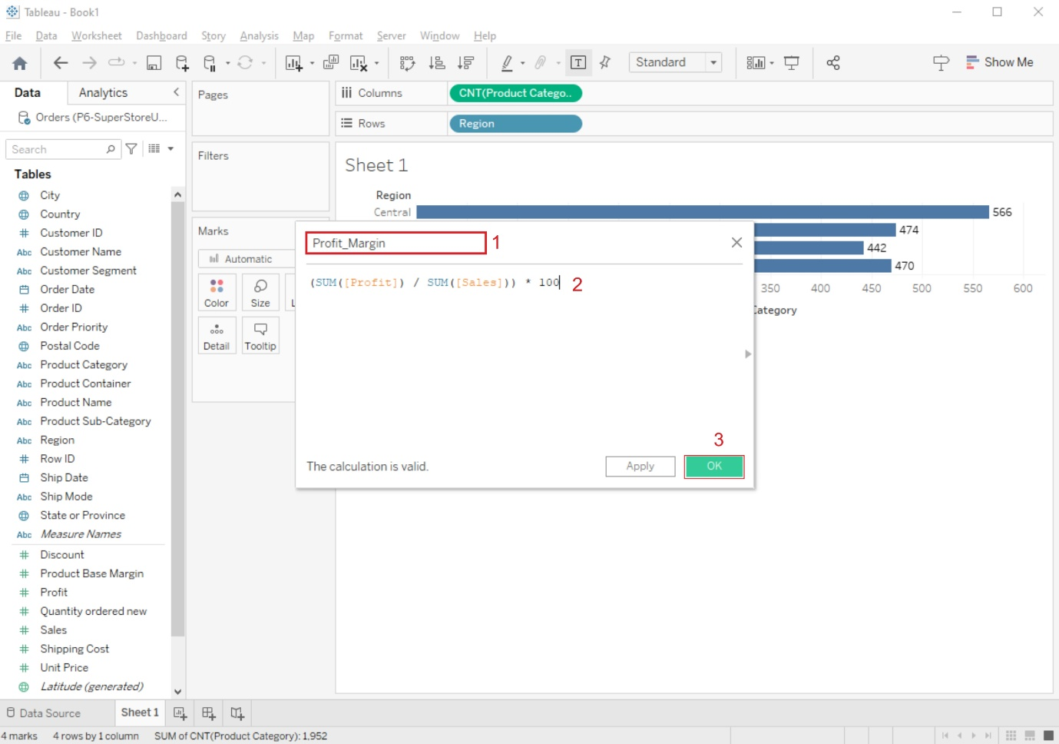

## 4. Use the Calculated Field in Your Worksheet:

You can now use the calculated field like any other field in your worksheet. Drag it to the Rows or Columns shelf, use it in filters, or create visualizations based on it.

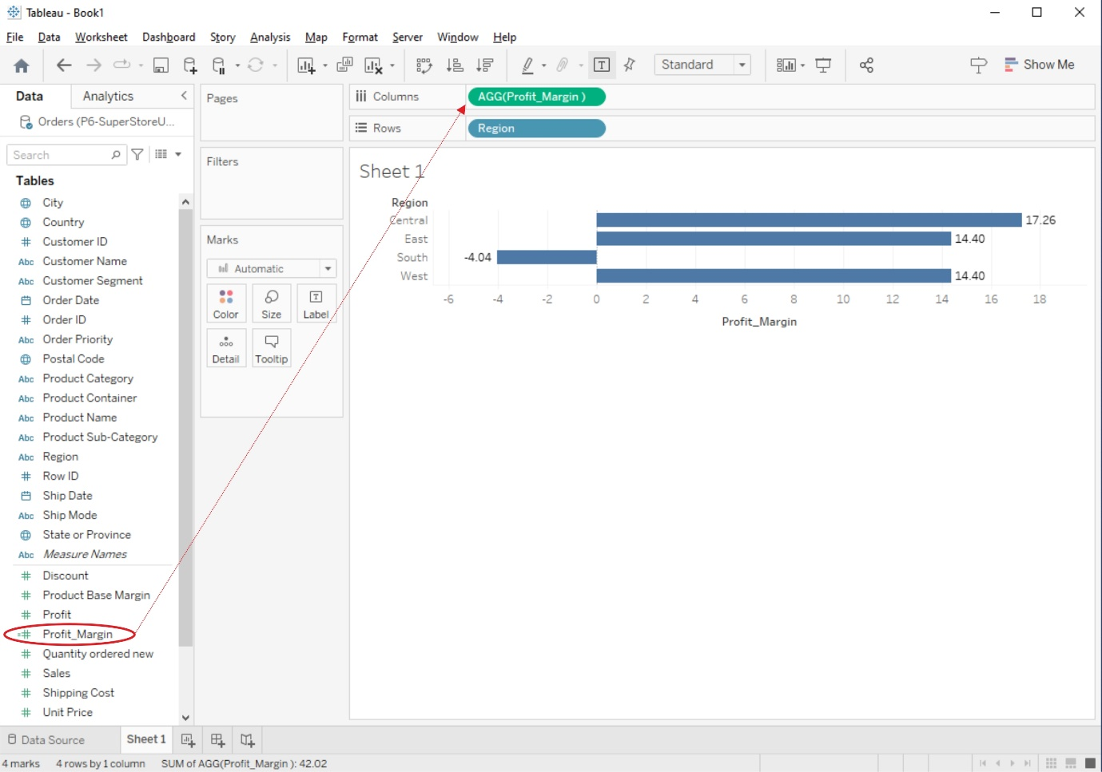

4. Applying new data calculations to your visualizations, Formatting Visualizations, Formatting Toolsand Menus, Formatting specific parts of the view.

## AIM:

# Applying new data calculations to your visualizations, Formatting Visualizations, Formatting Toolsand Menus, Formatting specific parts of the view.

## SOLUTION:

# Applying New Data Calculations to Visualizations

## 1. Drag and Drop Calculated Fields:

To apply your newly created calculated fields to a visualization, simply drag and drop them onto the appropriate shelves in your worksheet. For example, you can drag a calculated field to the Rows or Columns shelf, use it in filters, or place it on the Marks card to control the appearance of marks.

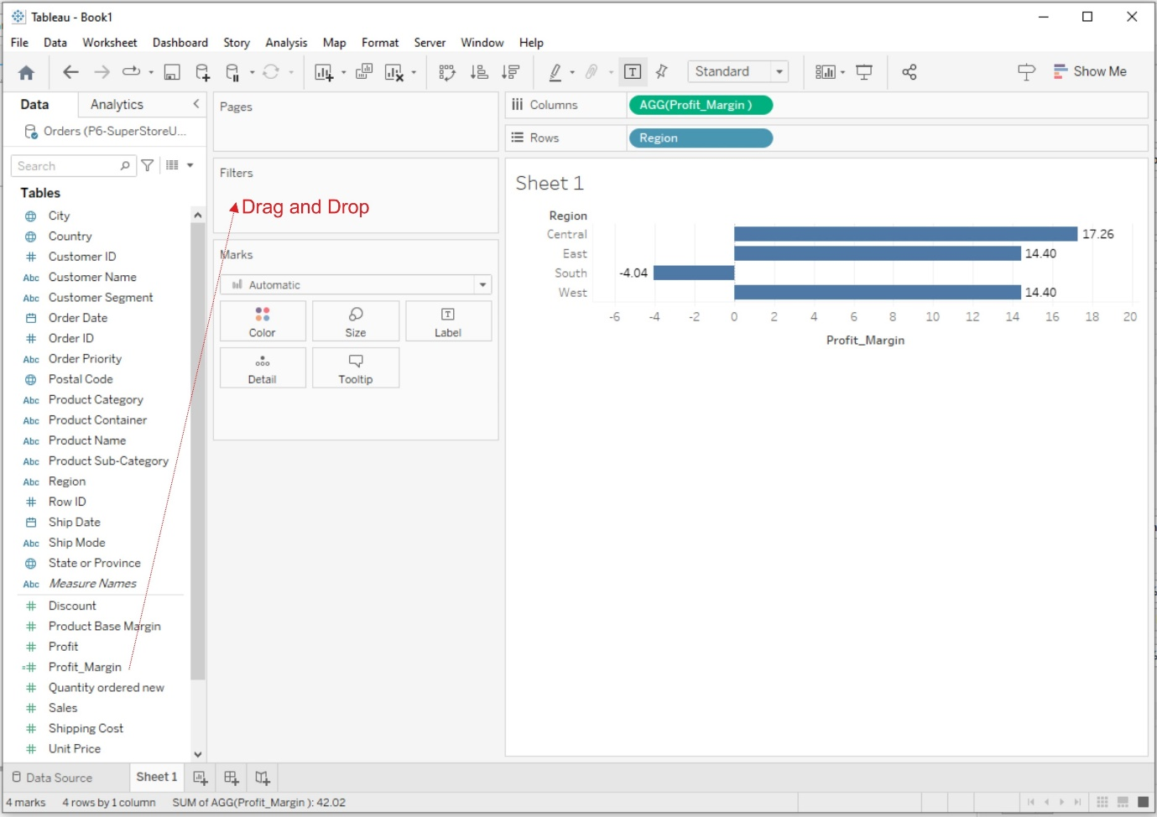

## 2. Filter with Calculated Fields:

Create filters using calculated fields to control which data points are displayed in your visualization. You can use calculated fields to filter by specific criteria, such as a calculated date range or a custom ranking.

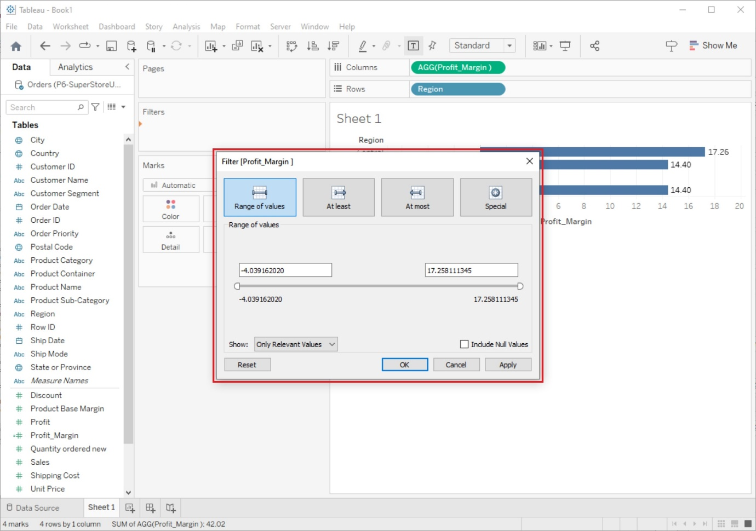

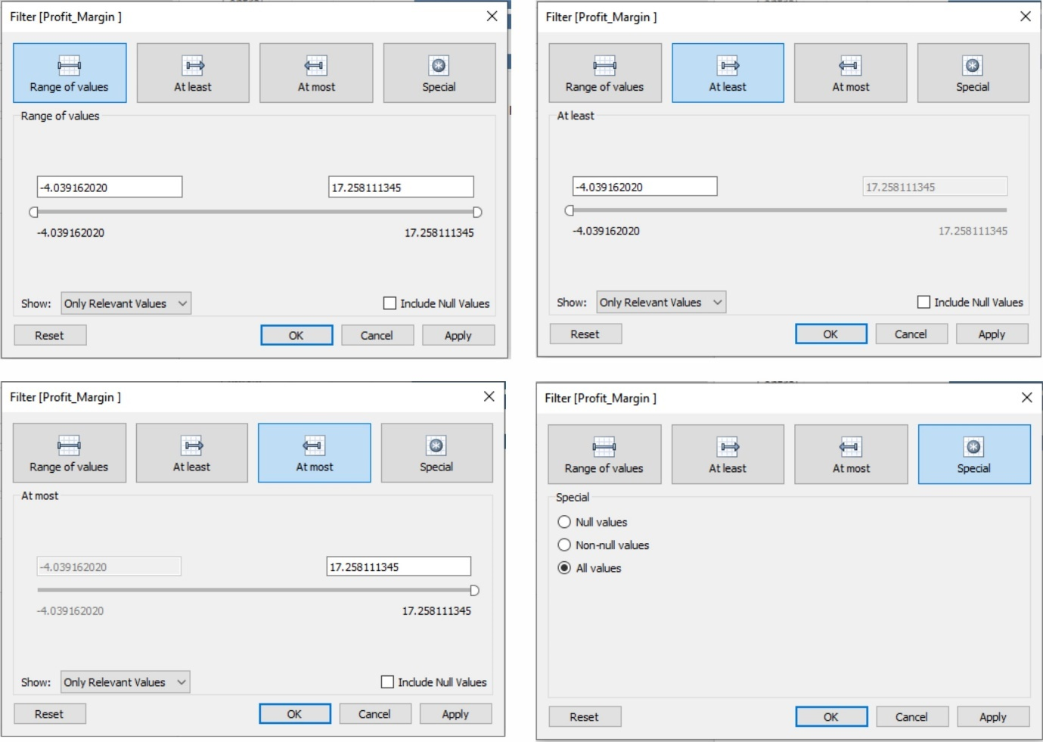

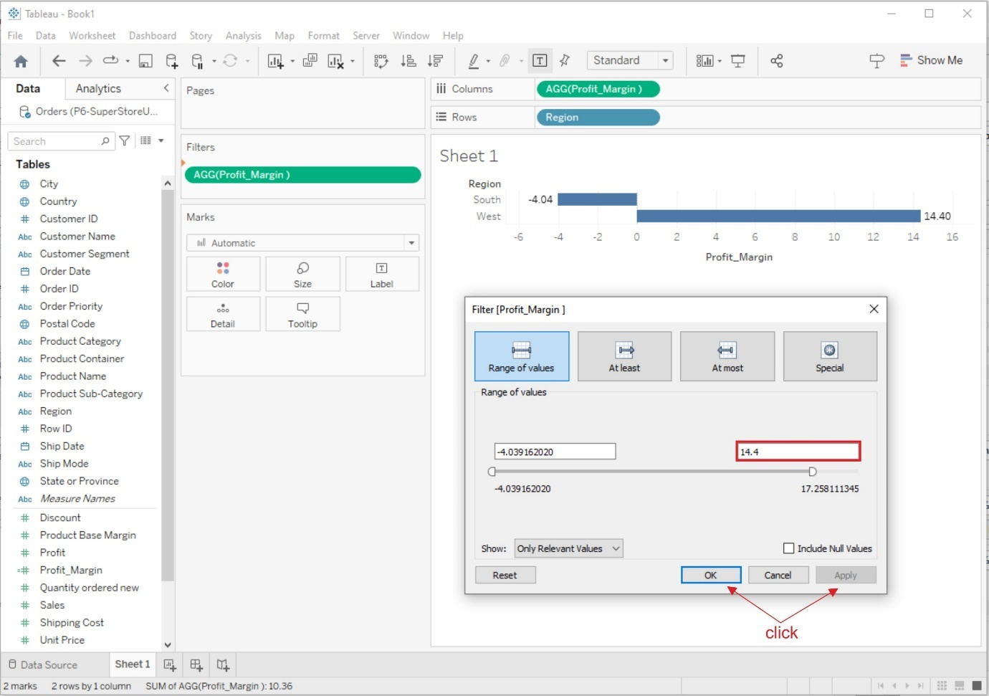

# Formatting Visualizations

Tableau provides a wide range of formatting options to make your visualizations more appealing and informative:

## 1. Format Pane:

On the left side of the Tableau interface, you'll find the Format pane. It allows you to format various aspects of your visualization, such as fonts, colors, lines, shading, and borders. Simply select the element you want to format and use the options in the Format pane to make changes.

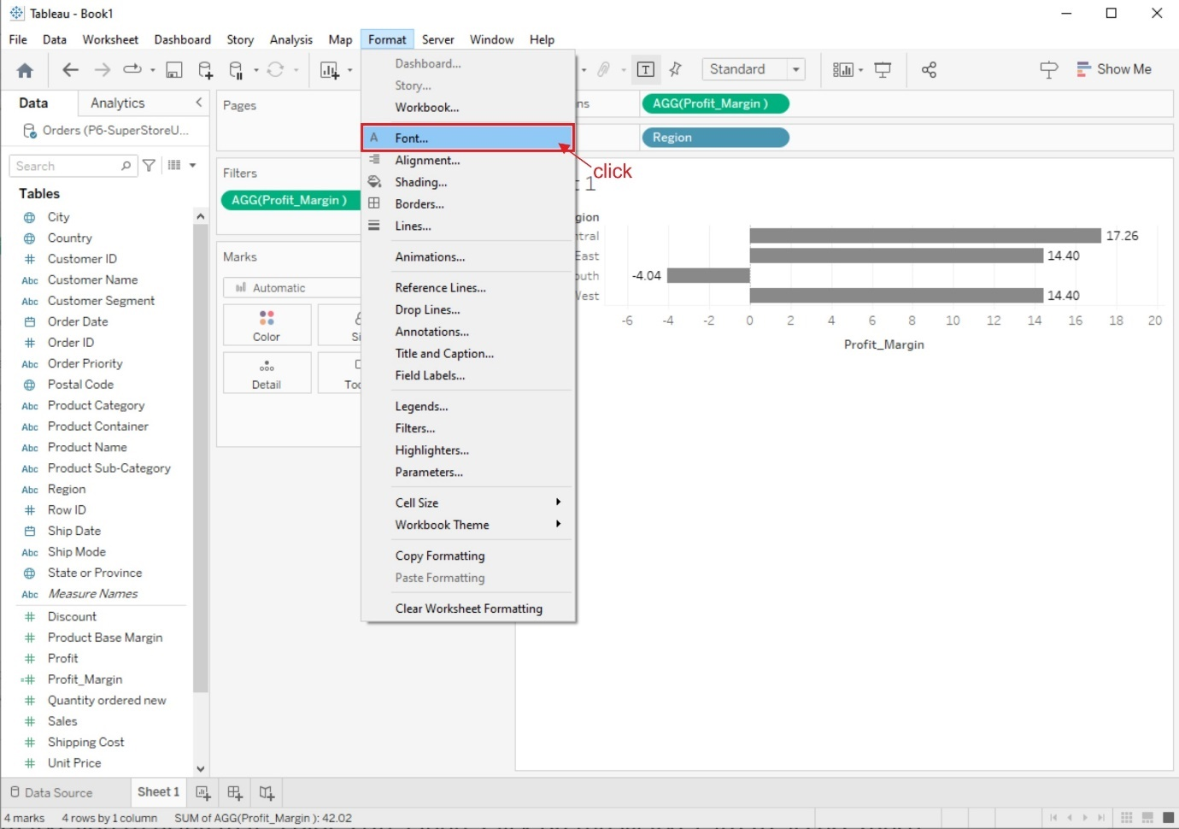

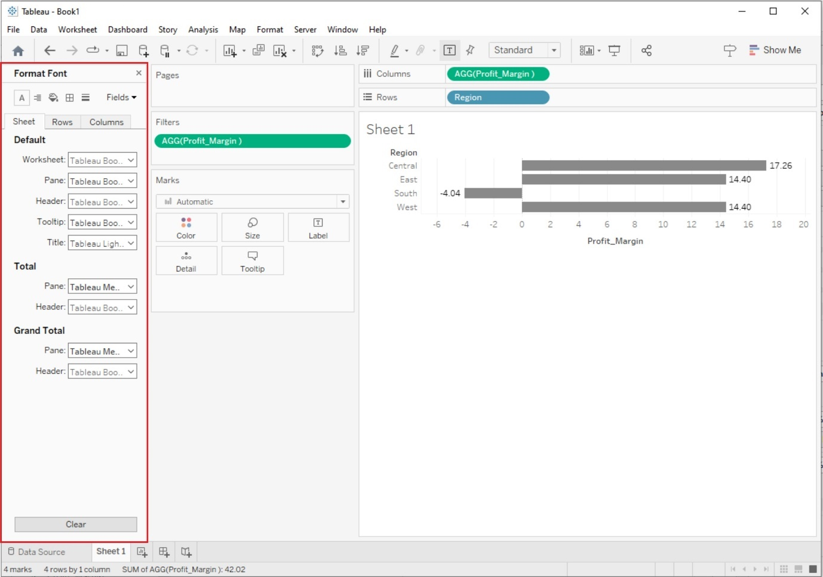

## 2. Marks Card:

The Marks card, located above your visualization, offers formatting options specific to the type of marks you're using (e.g., color, size, label). Click on the Marks card to access these options and modify how your data is represented.

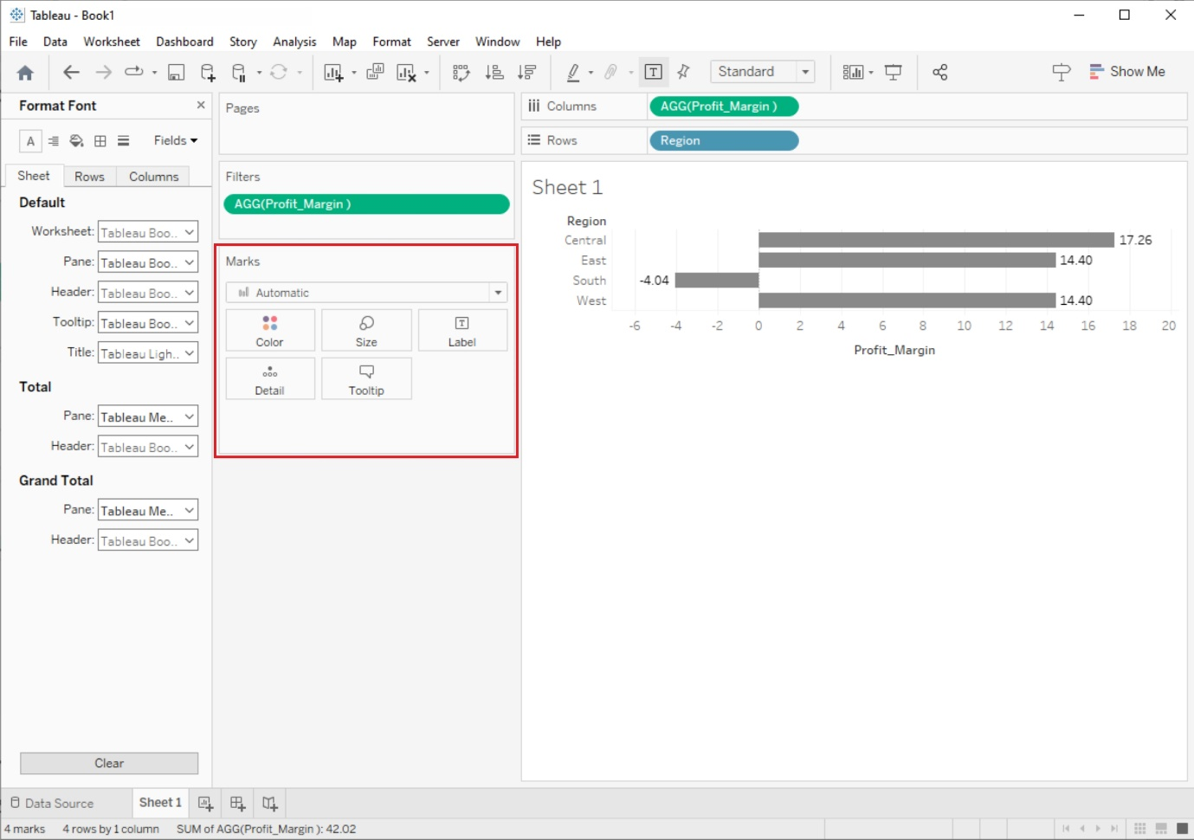

## 3. Axis and Gridlines:

You can format axis labels, titles, and gridlines to improve the readability of your visualization. Right-click on an axis or gridline to access formatting options.

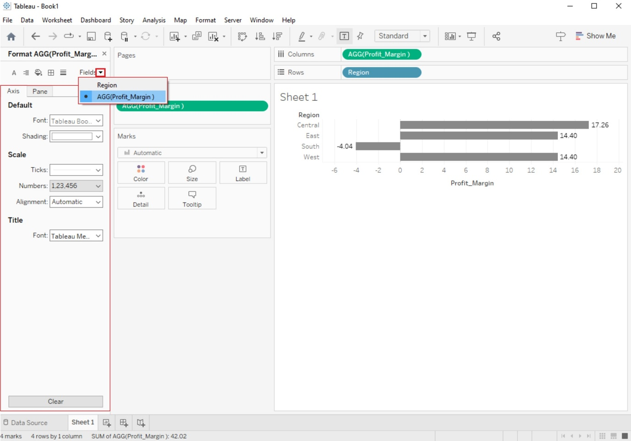

## 4. Legends and Color Scales:

Customize legends and color scales to provide context for your visualizations. You can change colors, labels, and the position of legends to match your data.

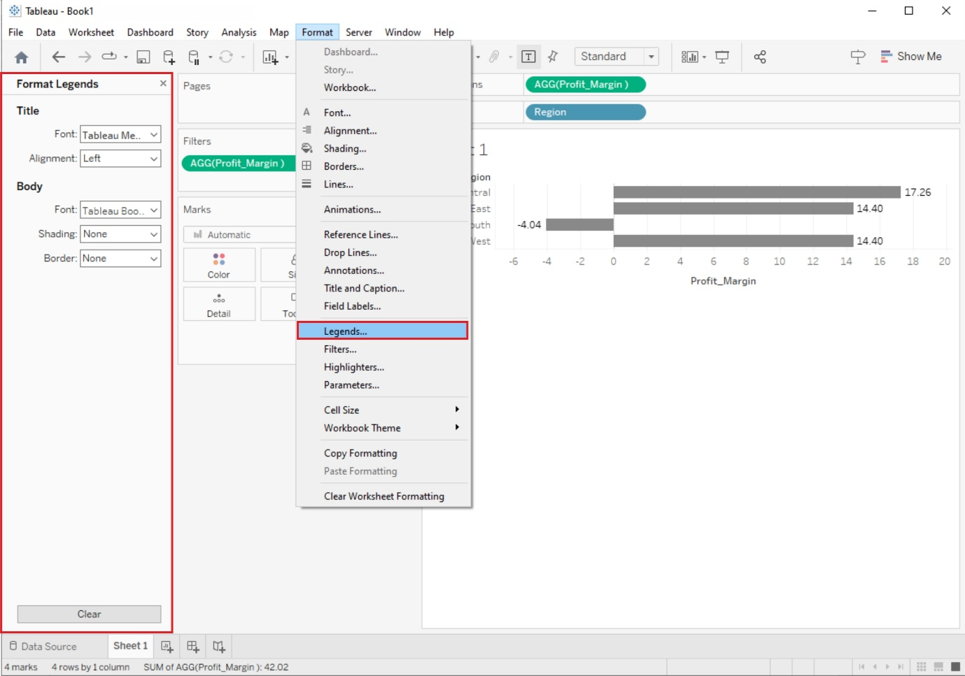

# Formatting Tools and Menus

Tableau provides several formatting tools and menus to help you refine the appearance of your visualizations:

## 1. Format Menu:

The Format menu at the top of the Tableau interface provides access to various formatting options, including font styles, shading, borders, alignment, and more. You can use this menu to format text, labels, and other elements.

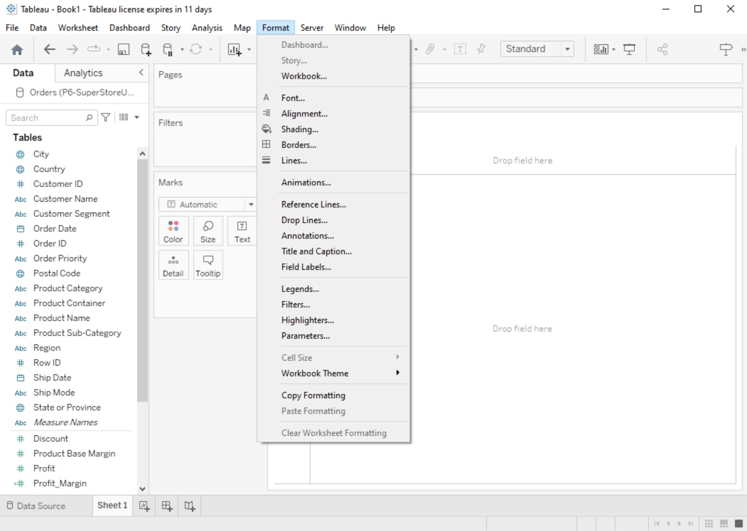

## 2. Worksheet Menu:

In the Worksheet menu, you'll find options to format the entire worksheet, including background color, borders, and worksheet title. You can also adjust the worksheet size.

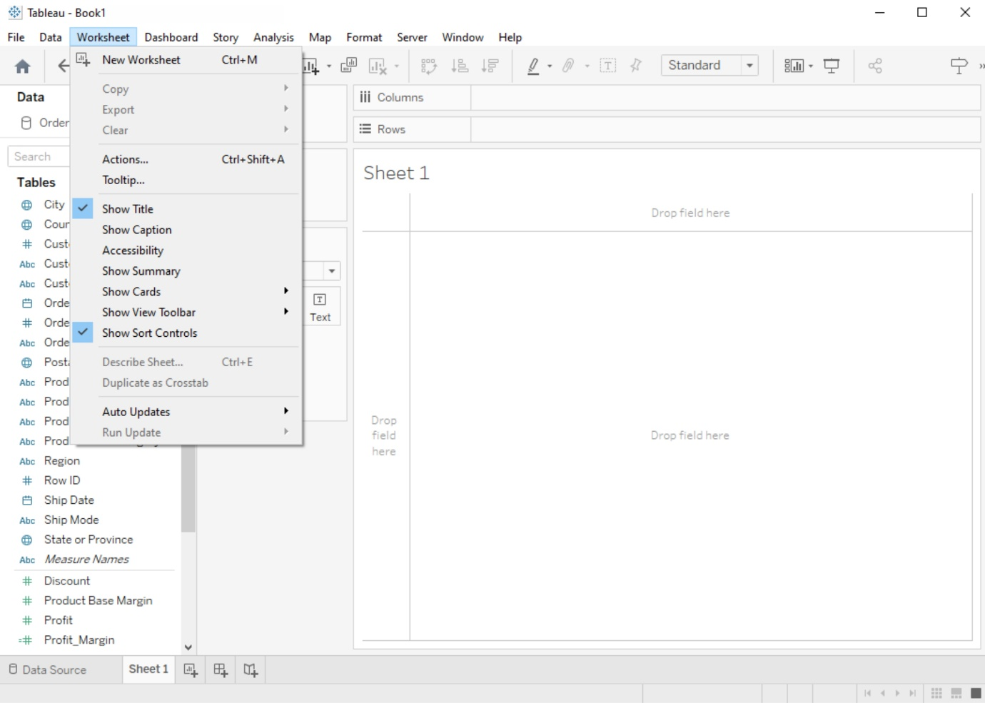

## 3. Dashboard Menu:

If you're working with dashboards, the Dashboard menu allows you to format the entire dashboard layout, including background, size, and title.

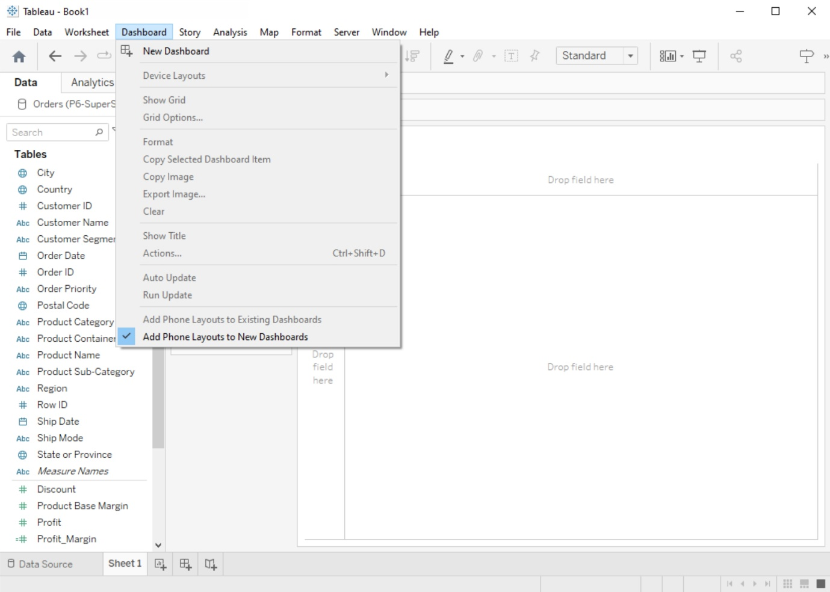

# Formatting Specific Parts of the View

Tableau lets you format specific elements of your visualization:

## 1. Annotations:

You can add annotations to your visualizations to highlight important points or provide additional context. Format these annotations using the options available when you right-click on an annotation.

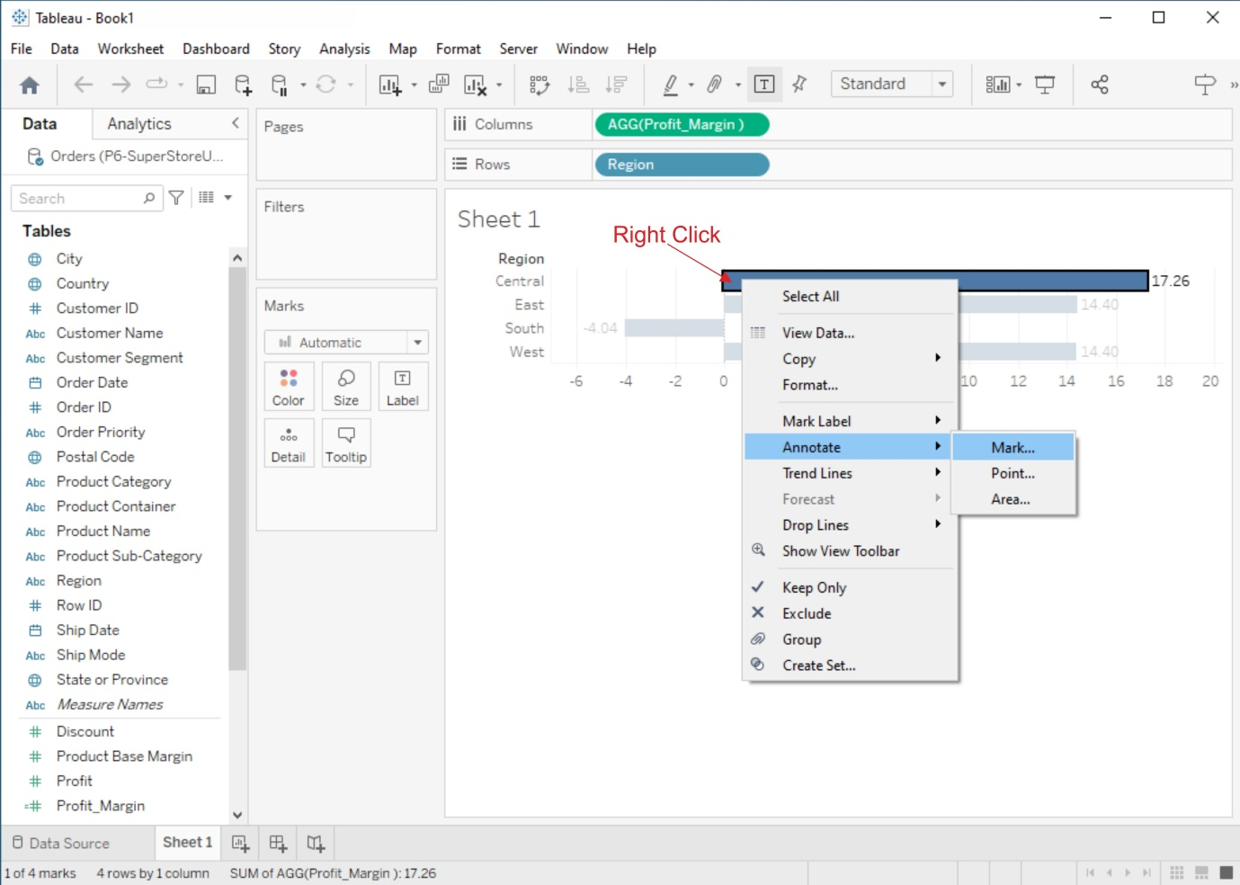

## 2. Tooltips:

Customize tooltips to display relevant information when users hover over data points. You can format tooltips to show or hide specific fields and control their appearance.

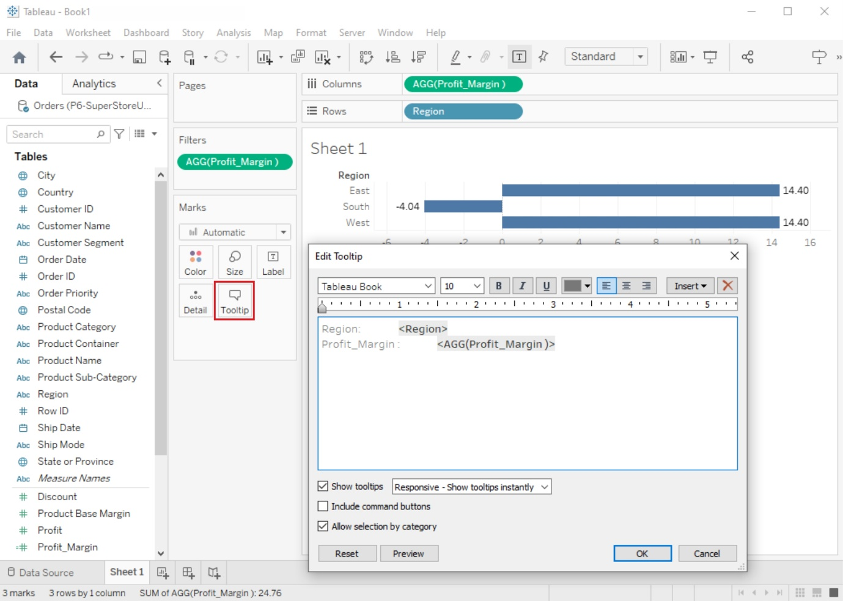

## 3. Headers and Titles:

Format headers, titles, and subtitles for clarity and consistency. Use the Format pane or the Format menu to adjust text formatting, alignment, and shading.

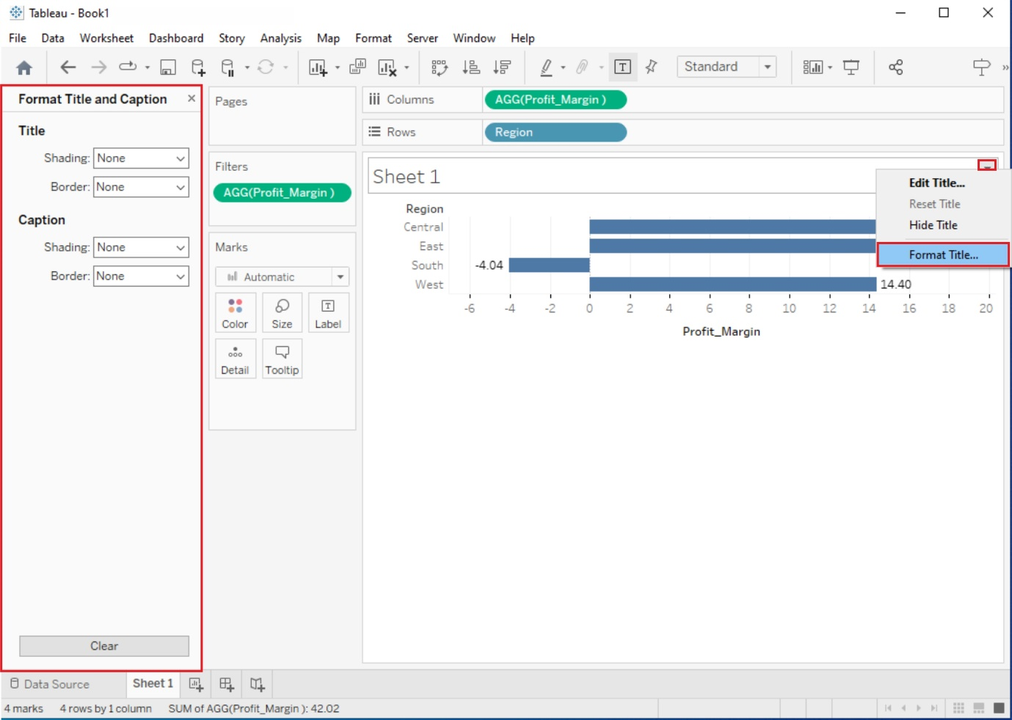

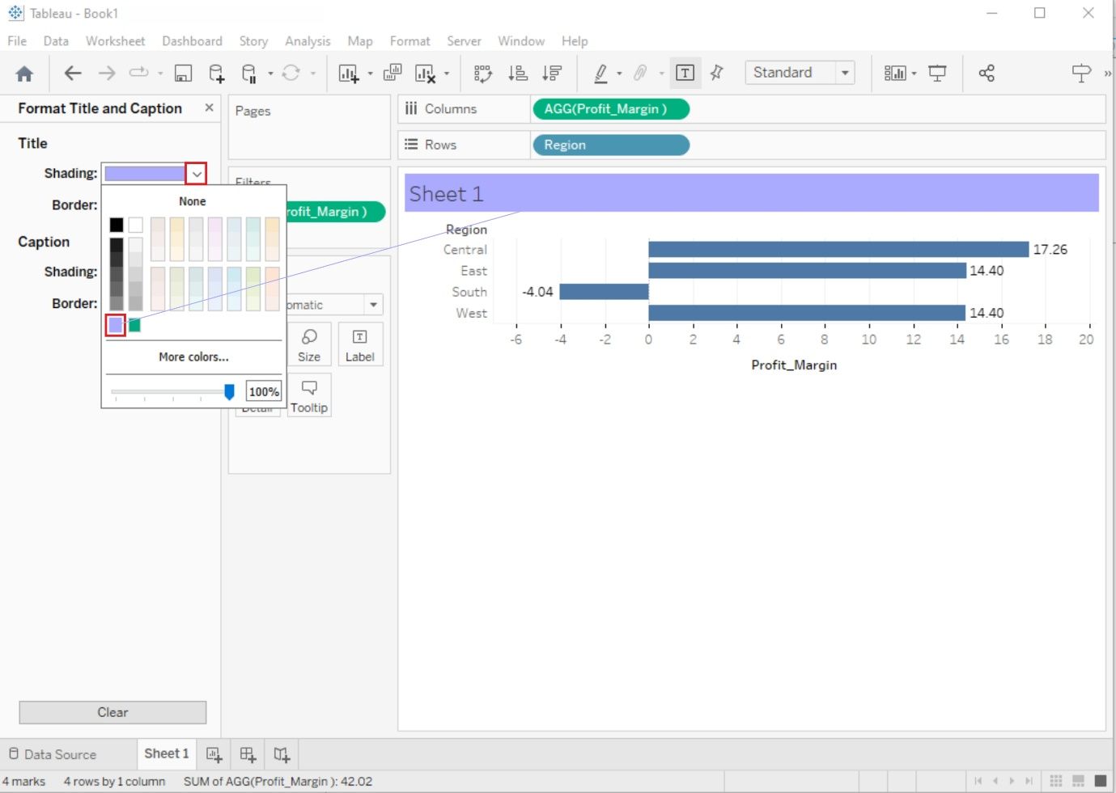

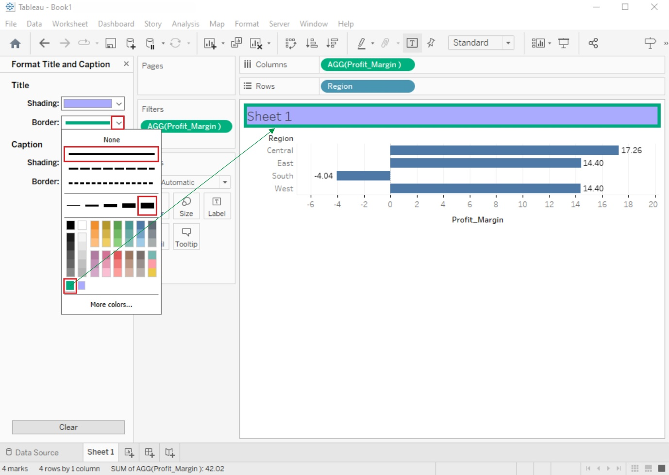

5. Editing and Formatting Axes, Manipulating Data in Tableau data, Pivoting Tableau data.

## AIM:

# Editing and Formatting Axes, Manipulating Data in Tableau data, Pivoting Tableau data.

## SOLUTION:

# Editing and Formatting Axes:

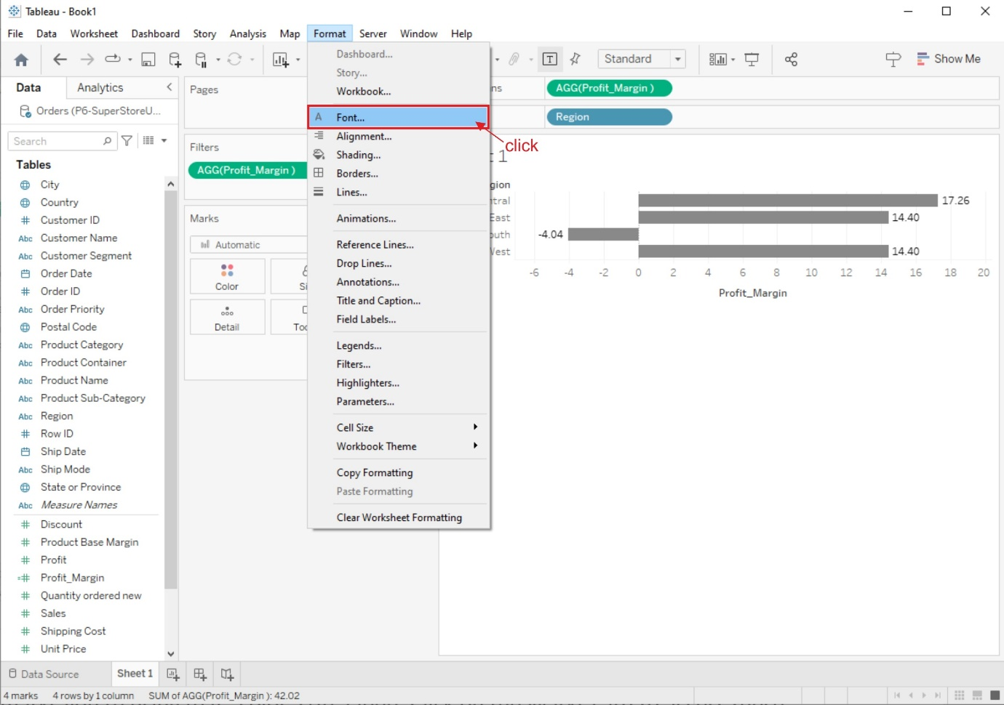



## 1. Edit Axis Title:

* Click on the axis title you want to edit.
* You can now modify the title text, font, size, color, and alignment using the Format pane or the toolbar at the top.

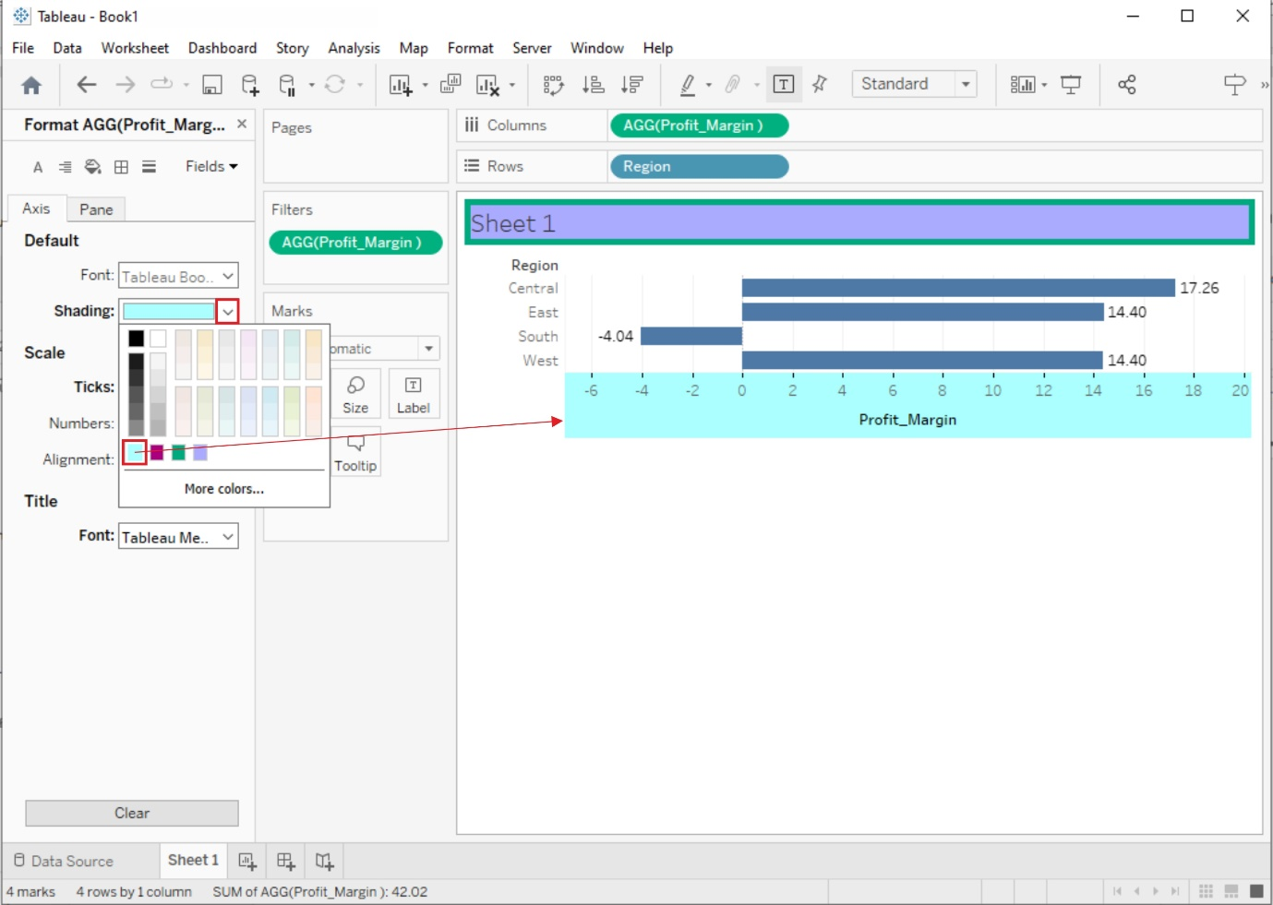

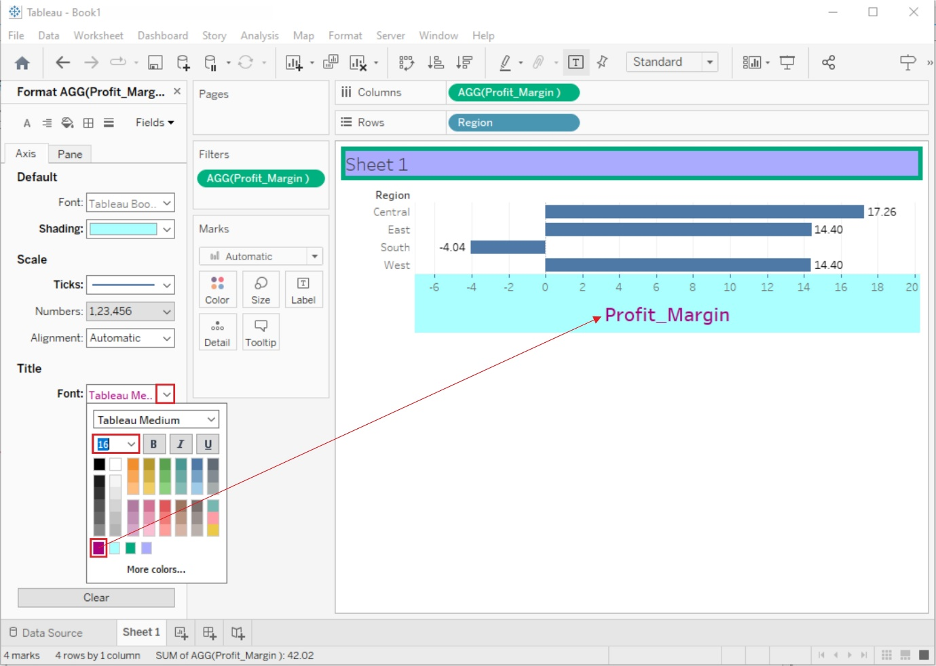

## 2. Edit Axis Labels:

* Right-click on an axis and select "Edit Axis."
* In the Edit Axis dialog box, you can change the formatting of labels, tick marks, and other axis-related properties.

## 3. Scale and Range:

* To change the scale or range of an axis, right-click on it and select "Edit Axis."
* In the dialog box, adjust the Minimum and Maximum values, scale, or range according to your needs.

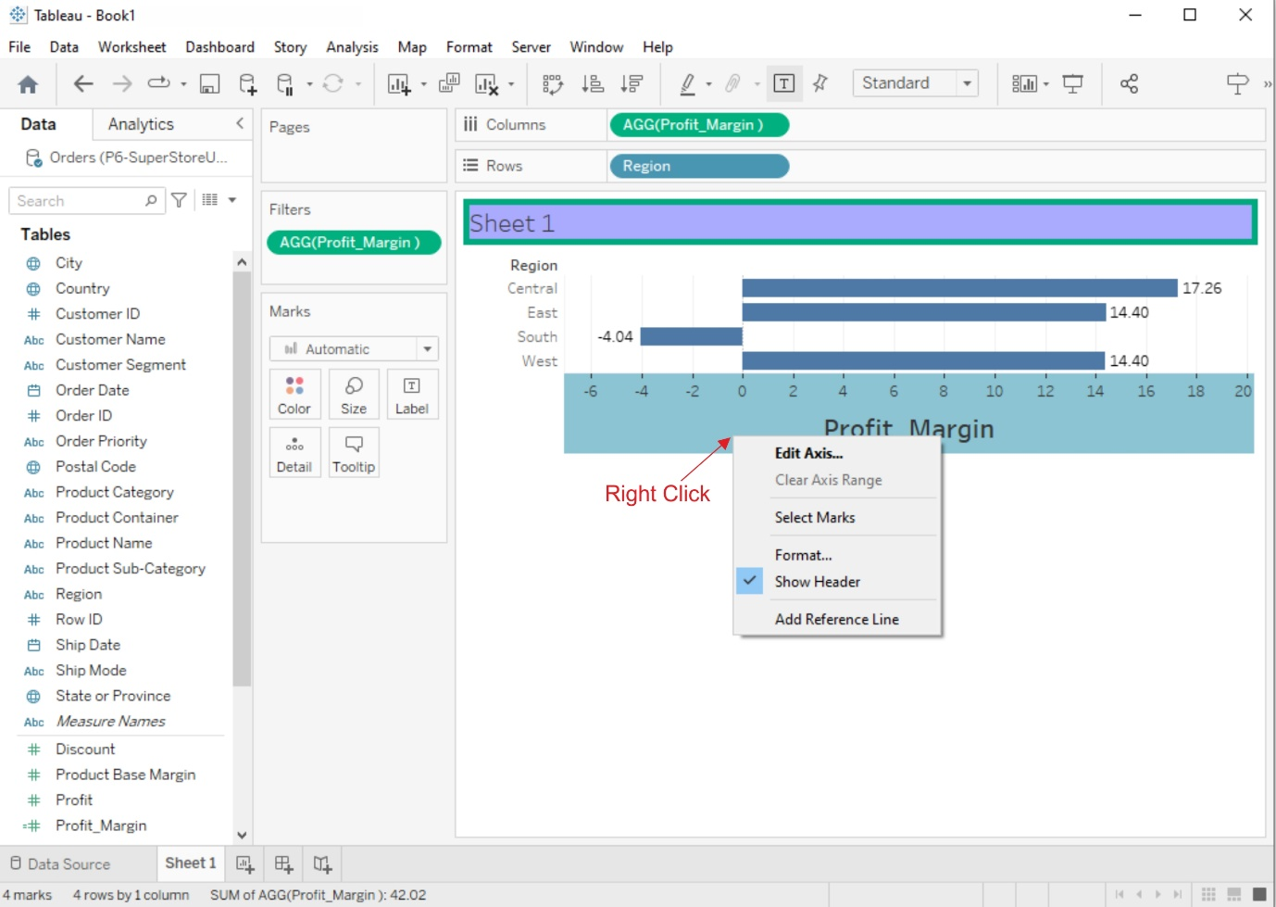

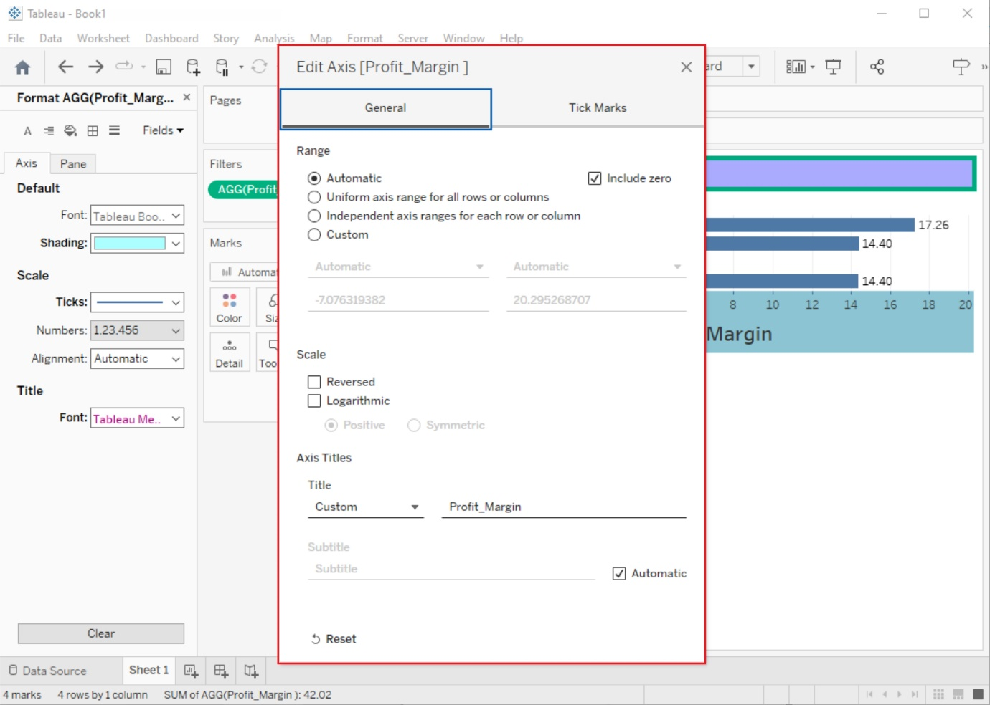

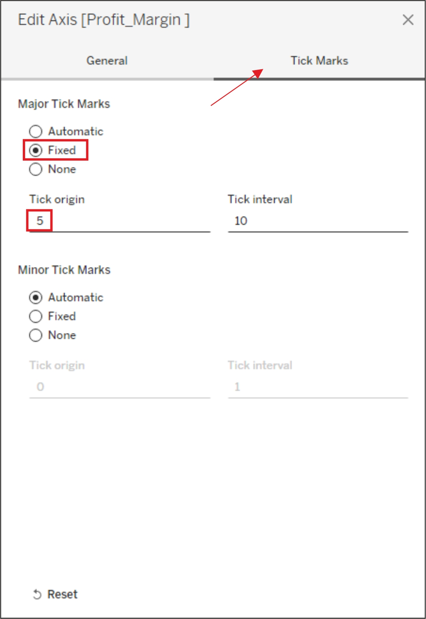

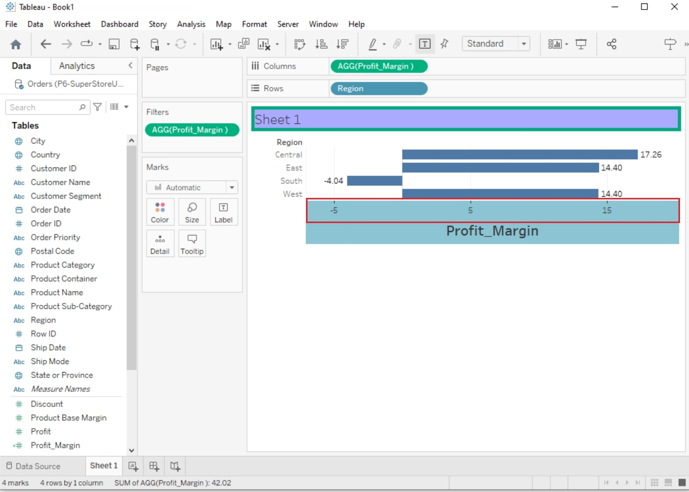

# Manipulating Data in Tableau data

# 

## Change Data Type

If Tableau has inferred a wrong data type for a column, the data type can be changed by clicking on the data type symbol in the column header

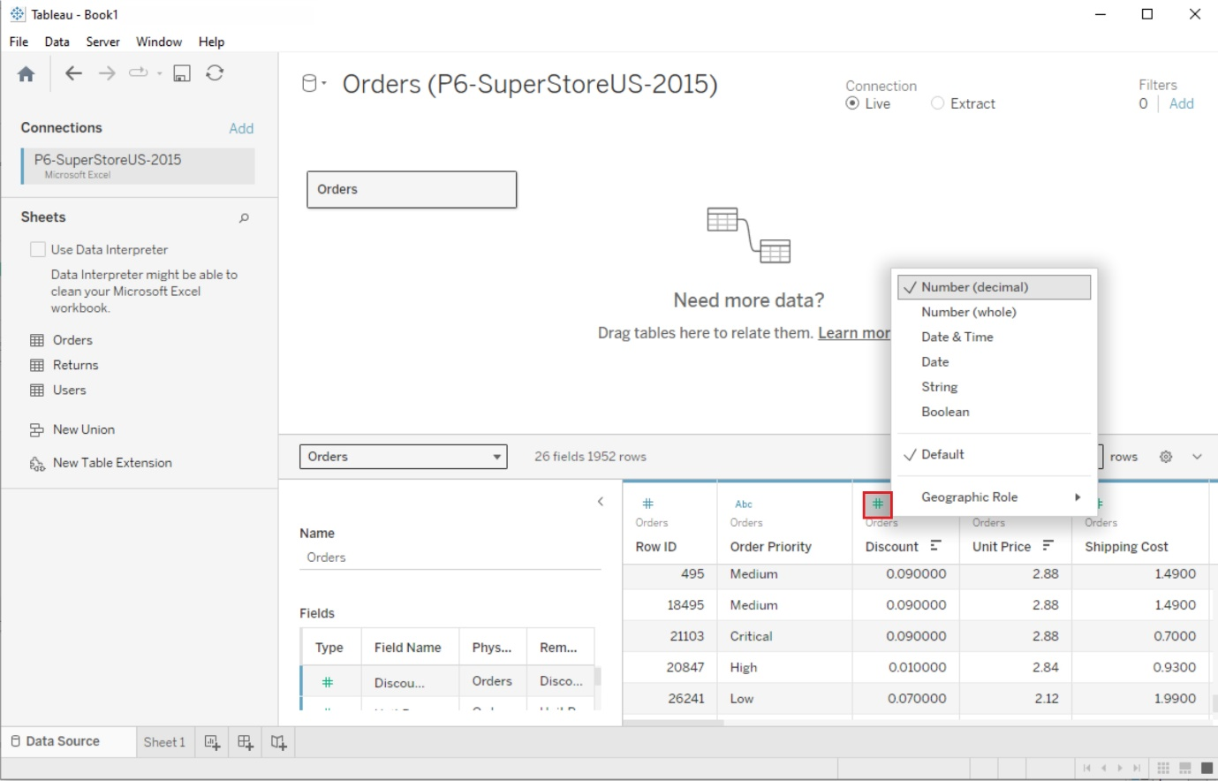

## New Column(Calculated Fields)

Calculated fields can be used if you need to create customized logic for manipulating certain data types or data values. There are a large-range of functions available in Tableau that can used individually or collectively for data manipulation.

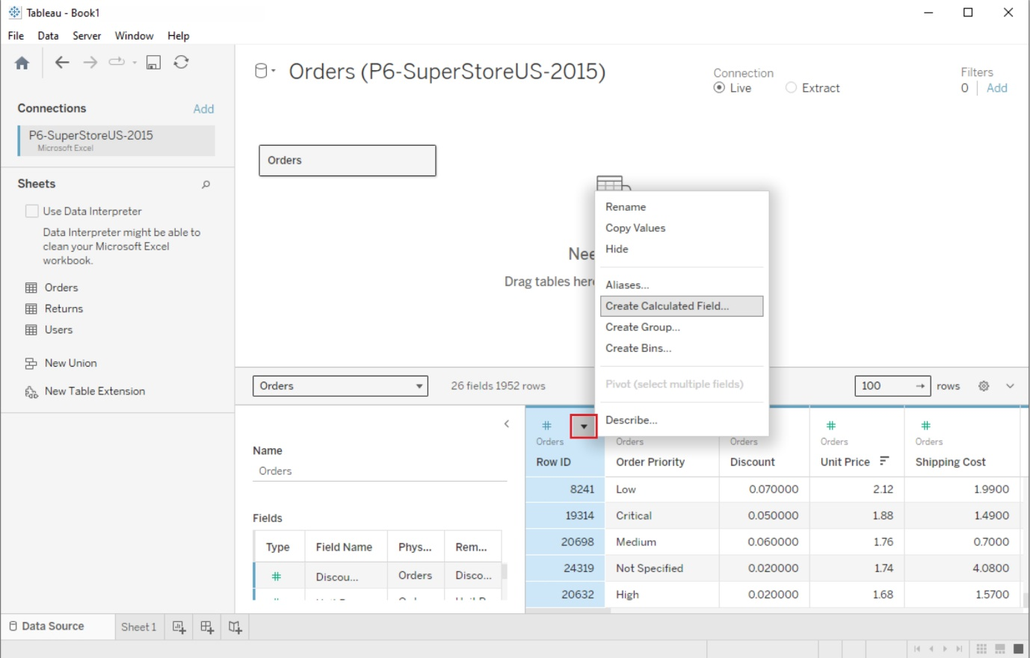

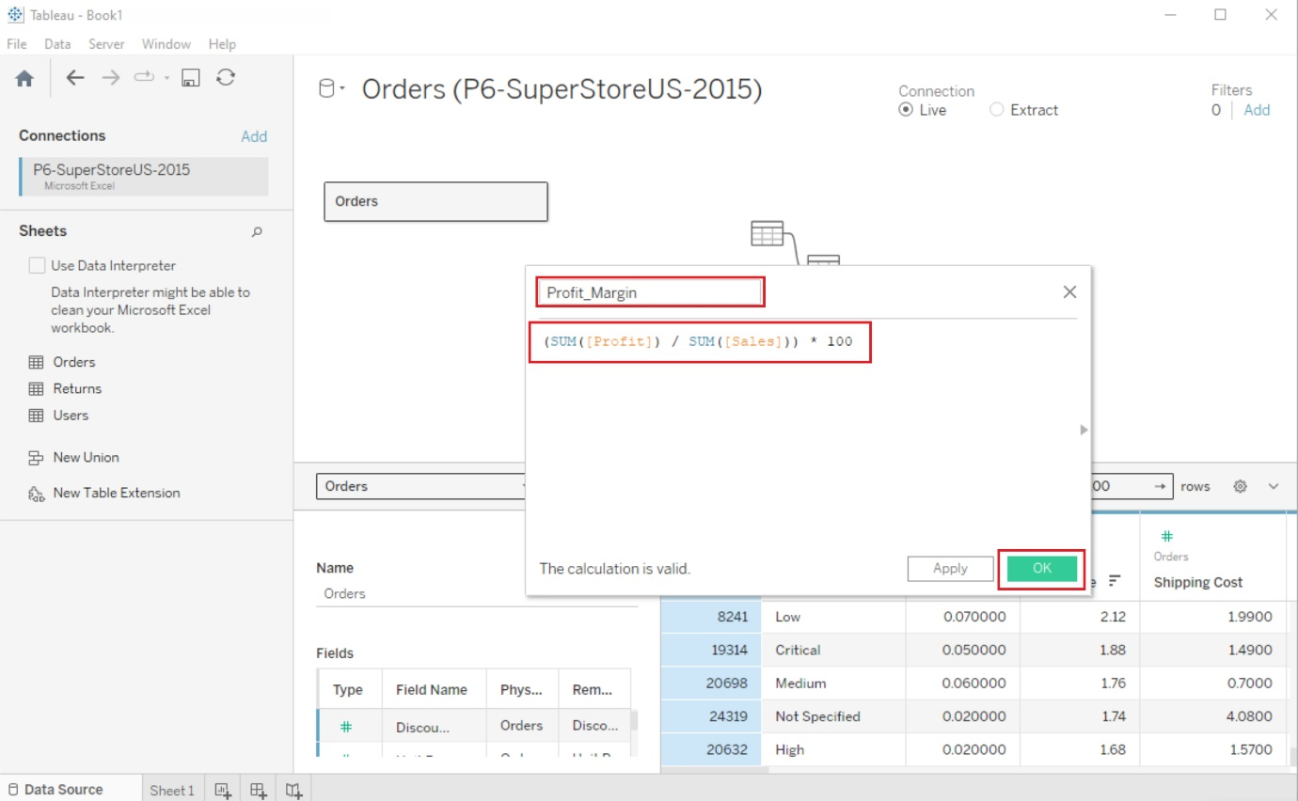

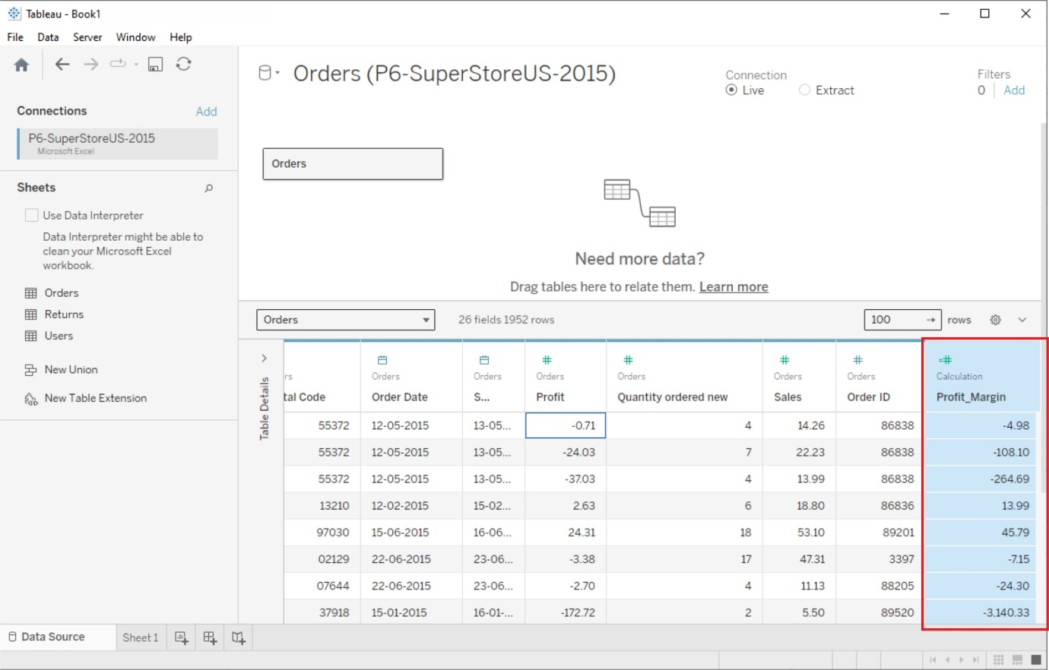

# Pivoting Tableau data

Data pivoting enables you to rearrange the columns and rows in a report so you can view data from different perspectives

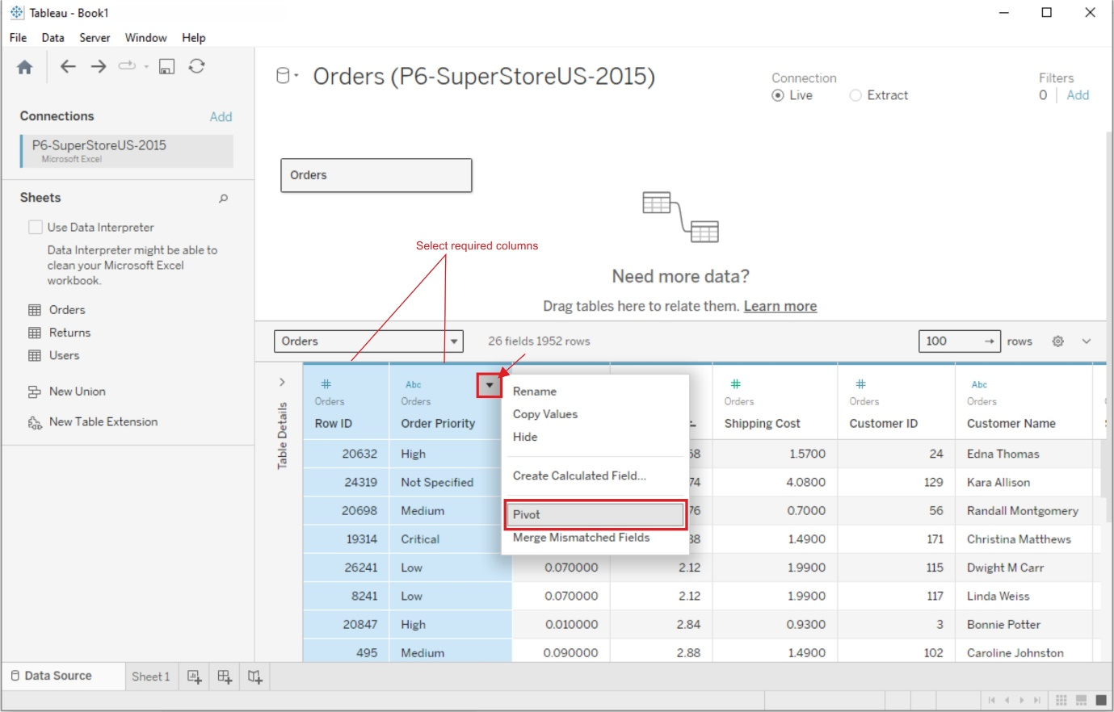

6. Structuring your data, Sorting and filtering Tableau data, and Pivoting Tableau data.

## AIM:

# Structuring your data, Sorting and filtering Tableau data, Pivoting Tableau data.

## SOLUTION:

**Dataset: Olympic Athletics**

SHEET1:

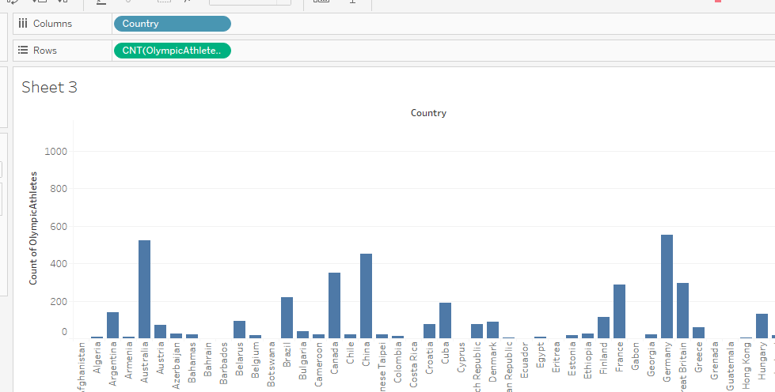

SHEET2:

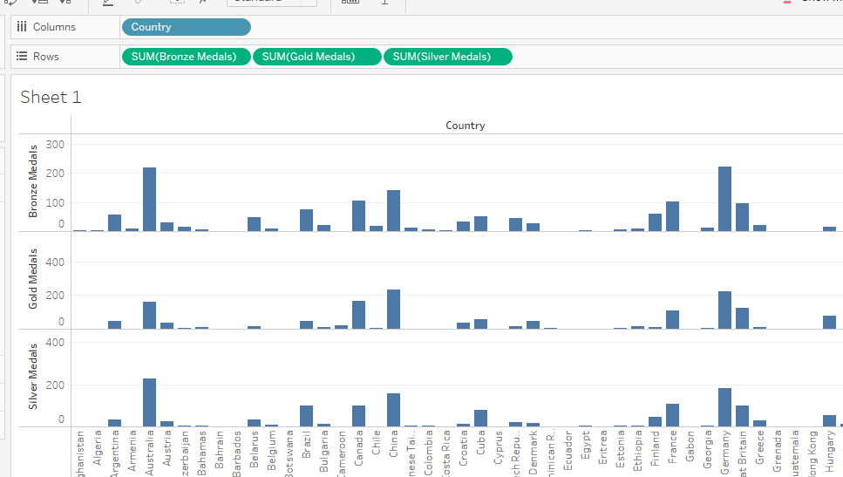

**Structuring the Data:**

Structured data refers to data that is organized and formatted in a specific way to make it easily readable and understandable by both humans and machines. This is typically achieved through the use of a well-defined schema or data model, which provides a structure for the data.

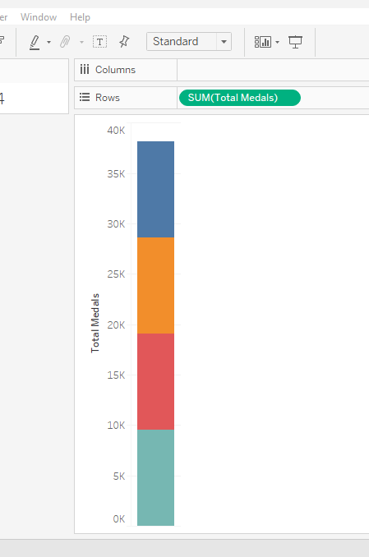

Average Age of Sports Person:

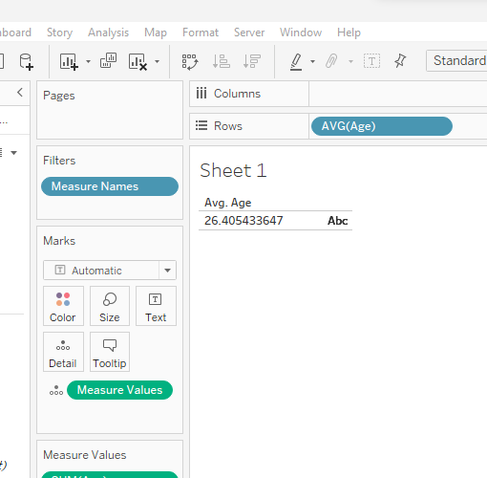

7. Advanced Visualization Tools: Using Filters, Using the Detail Panel, Using the Size Panels, Customizing Filters, Using and Customizing tooltips, Formatting your data with colors.

## AIM:

**Advanced Visualization Tools: Using Filters, Using the Detail Panel, Using the Size Panels, Customizing Filters, Using and Customizing tooltips, Formatting your data with colors.**

## SOLUTION:

Dataset: Superstore

SHEET1:

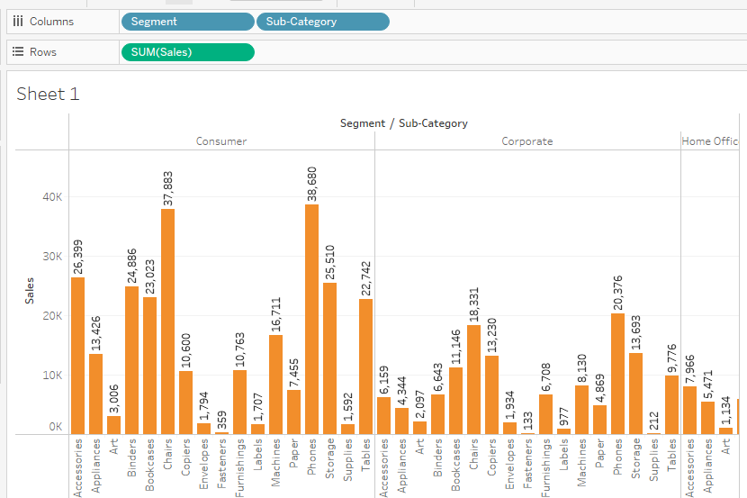

SHEET2:

**Create Advance Filters:**

From Ordered data 🡪 Right Click and select **set🡪** you will get popup window

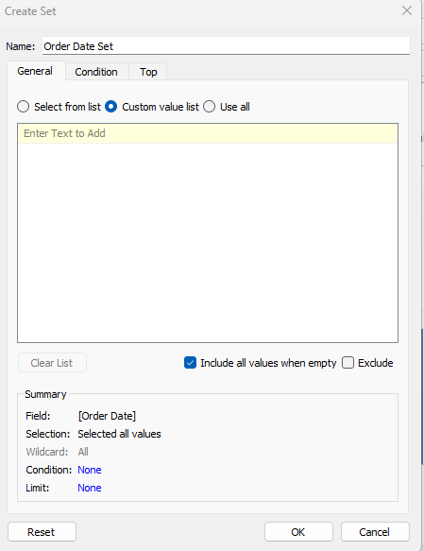

Name: Select as Year exp:2014

Year wise list select from the bottom tab

Click on ok

Repeat the above steps for year 2015 , click on ok

**Next Step:**

Select Create parameter from the Left Panel🡪

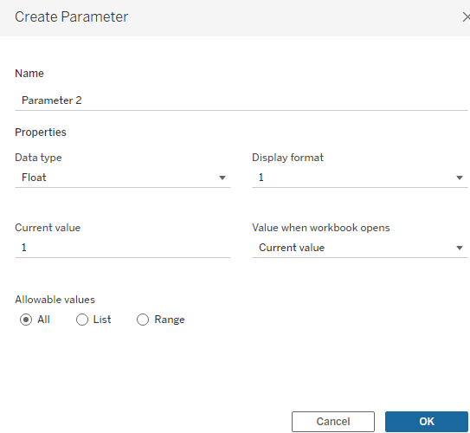

Change the name as **Filter.**

Data type: **String**

Allowable values select the check box as **L**ist

Fill Value & Data type Colum with year

Click on ok

**Next Step:**

Right click on Filter 🡪 Select the Calculation filed give name as USER FILER

Type the formula as

|  |
| --- |
| CASE [ FILTER]  WHEN “2014” THEN [2014]  WHEN “2015” THEN[2015]  END |

Click ok

**Next Step:**

Go to the Bottom left panel select USER FILTER drop it into the FILTER BOX

You will have popup window: select check box as True

**Next Step:**

Right Click on Filer and click show parameter , you can observe filter will appear in the right side of the sheet.

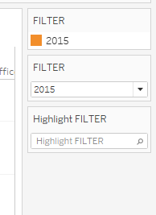

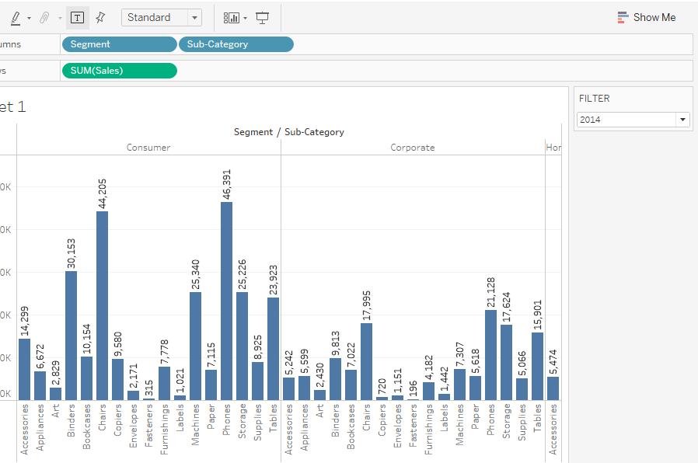

8. Creating Dashboards &amp; Storytelling, creating your first dashboard and story, Design for different displays, adding interactivity to your dashboard, Distributing &amp, Publishing your visualization

AIM:

Creating Dashboards &amp; Storytelling, creating your first dashboard and story, Design for different displays, adding interactivity to your dashboard, Distributing &amp, Publishing your visualization

SOLUTION:

Dataset: Olympic Athletes

SHEET1:

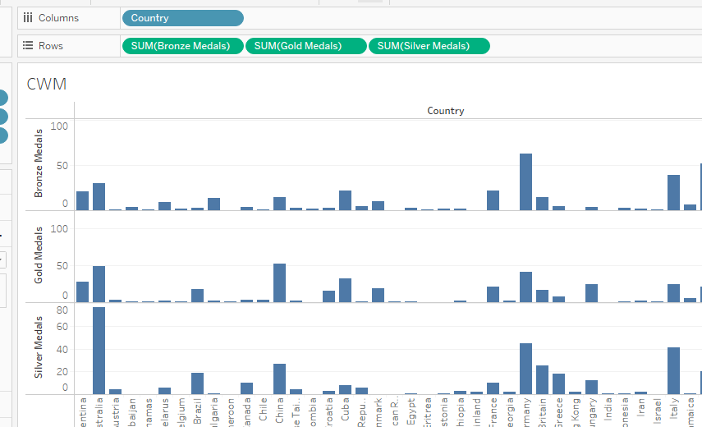

SHEET2:

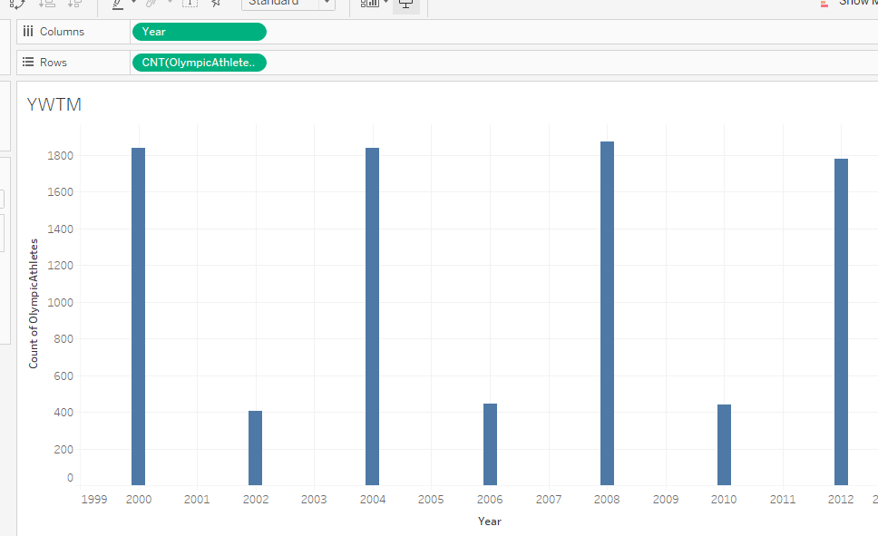

SHEET3:

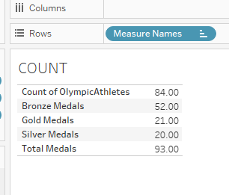

Creating your Dash Board:

Dashboard: A dashboard also consist of a number of views that allow you to compare various sets of data at once. A dashboard that displays all the views will be created if, for instance, you have a set of views that you merely evaluate each day and don’t need to travel to individual worksheets. Dashboards are accessed from the workbook’s lowest-level tabs similarly to worksheets. A sheet’s data is linked to any dashboards that contain it, so when you edit a sheet, those dashboards also change, and vice versa. The most recent data from the information source updates both sheets and dashboards

**Steps for Create a Own Dashboard:**

Select The sheet--🡪 Analysis Tab -🡪 Select Calculation Field🡪 Type Name as Dash1 and bottom Colum type as ‘Dashboard1’ then click OK

**How to Apply Color to the Dashbaod**

Go to Format tab -🡪 Select Shading 🡪 ln the leftside of the sheet you will find change color tab 🡪 Select More Colors Select your own Color

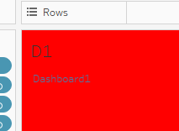

Repeat the above steps for Dashboard2

**After Creating Sheets and Dashboards:**

**Step1:**

Go the New Dashboard

Select Vertical Container in the Objective Menu 🡪 Drag and drop it into Visualization Area

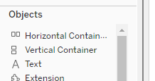

**Step2:**

Drag and Drop the Dashboard1, and Dashboard2 into the Vertical Container

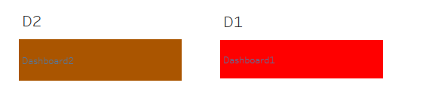

**Step3:**

Select the Horizontal container Drop all the Sheets into the Container

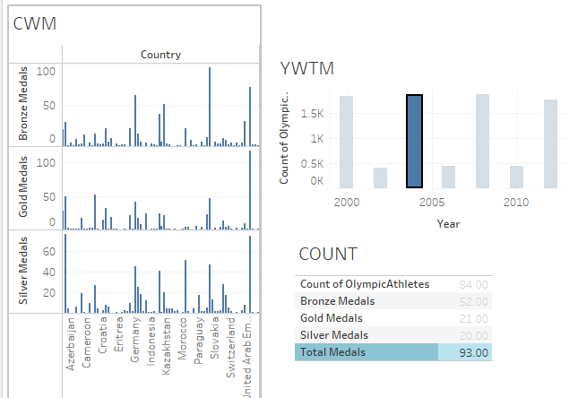

**Step4:**

Select the First **Dash board1**

Goto🡪 Dashboard Tab-🡪 Select **Actions** in the list you will get the below window 🡺 from that select the filter🡪 click on **Add** Filter🡪 Select Filter for Dashboad

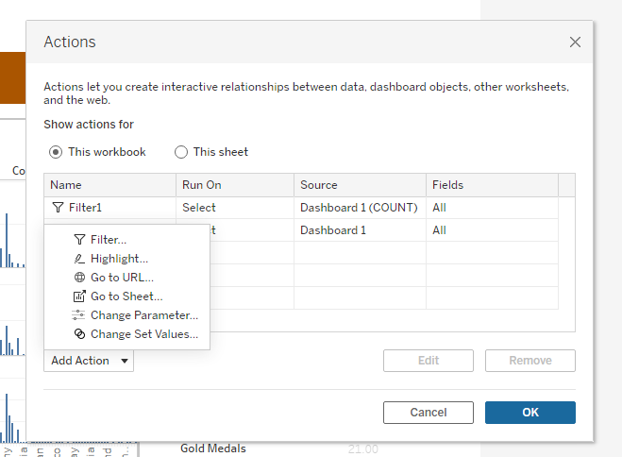

After Selecting filter, you will get 🡪new panel for selecting your sheets for Dashboard

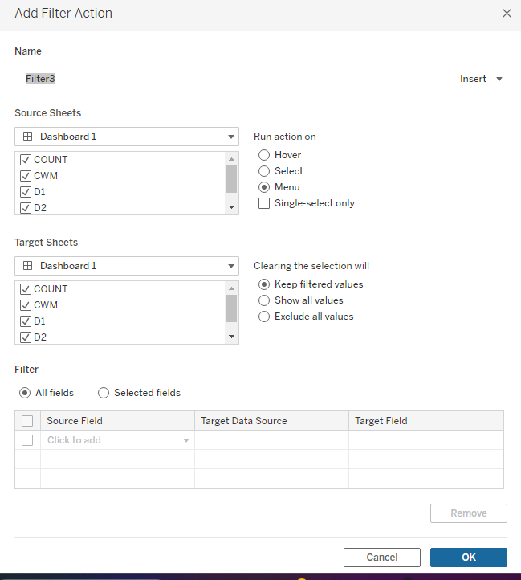

From Sourcesheet🡪Select the **Sheets** for your Dashboard, Select the Run Action in the right-side check box **selec**t the option then click ok at the bottom of the panel.

**Step5:**

You Can Visualize the Data -🡪 Dashboard Wise -> Apply Filer observe the changes

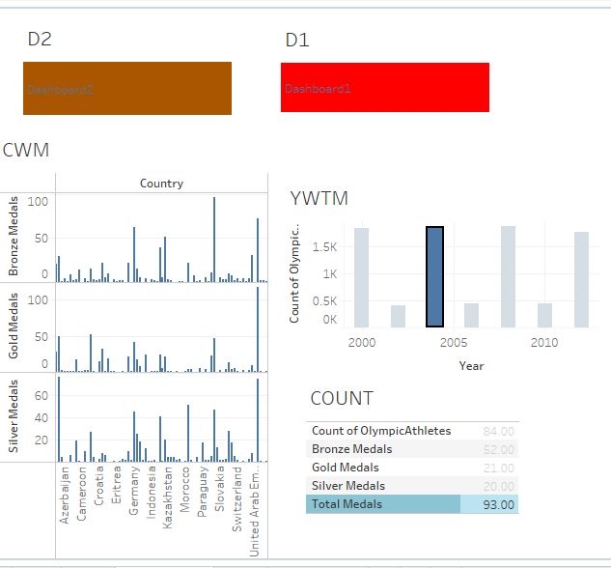

9.Tableau File Types, Publishing to Tableau Online, Sharing your Visualizations, Printing and Exporting

AIM:

Tableau File Types, Publishing to Tableau Online, Sharing your Visualizations, Printing and Exporting

SOLUTION:

Tableau File Types:

* **Workbooks (.twb)** – Tableau workbook files have the .twb file extension. Workbooks hold one or more worksheets, plus zero or more dashboards and stories.
* **Bookmarks (.tbm)** – Tableau bookmark files have the .tbm file extension. Bookmarks contain a single worksheet and are an easy way to quickly share your work.
* **Workbooks (.twbx)** – Tableau packaged workbooks have the .twbx file extension. A packaged workbook is a single zip file that contains a workbook along with any supporting local file data and background images. This format is the best way to package your work for sharing with others who don’t have access to the original data.
* **Extract (.hyper)** – Tableau extract files have the .hyper extension. Extract files are a local copy of a subset or entire data set that you can use to share data with others when you need to work offline and improve performance.
* **Data Source (.tds)** – Tableau data source files have the .tds file extension. Data source files are shortcuts for quickly connecting to the original data that you use often. Data source files do not contain the actual data but rather the information necessary to connect to the actual data as well as any modifications you've made on top of the actual data such as changing default properties, creating calculated fields, adding groups, and so on.
* **Packaged Data Source (.tdsx)** – Tableau packaged data source files have the .tdsx file extension. A packaged data source is a zip file that contains the data source file (.tds) described above as well as any local file data such as extract files (.hyper), text files, Excel files, Access files, and local cube files. Use this format to create a single file that you can then share with others who may not have access to the original data stored locally on your computer.

**Publish Tableau Online:**

In Tableau Desktop, open the workbook you want to publish. Select Server > Publish Workbook. If the Publish Workbook option does not appear on the Server menu, make sure a worksheet or dashboard tab is active (not the Data Source tab). If necessary, sign in to a server. For Tableau Cloud, enter **https://online.tableau.com**.

[**To share visualizations in Tableau, you need to**](https://dataisgood.com/tableau-public-guide-for-how-to-sharing-your-visualizations/)

1. Click on "Share" in the top right corner of your visualization.
2. Select a sharing option, such as embedding the visualization on a website, sharing it on social media, or emailing a link to the visualization.
3. Customize the size of the visualization and copy the code to your website if embedded.
4. Open the Actions menu for the content you want to share.
5. Click on Share from the list of menu items.

Exporting Data

You can either copy a selection of data from a view to use in another application or you can export all the data from the worksheet to an Access database.

To copy data to the Clipboard:

1. Select the data in the view that you want to copy.
2. Right-click (Control-click on Mac) the selection and select **Copy** > **Data**.
3. Open another application such as MS Word or MS Excel and select **Edit** > **Paste**.

Note: You can also copy the data as a cross-tab for use in Microsoft Excel. Select **Copy** > **Crosstab** on the context menu.

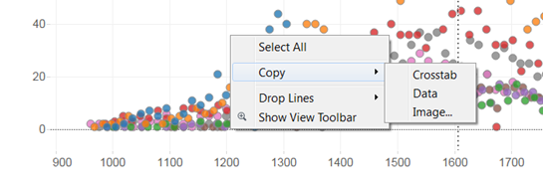

10. Creating Custom Charts, Cyclical data and Circular area charts, Dual Axis Chats

AIM:

Creating Custom Charts, Cyclical data and Circular area charts, Dual Axis Chats

SOLUTION:

Dataset: Superstore

SHEET1:

Colum: Drop the Subcategory

Row: Sum of sales, twice for visualization and changing the plot type

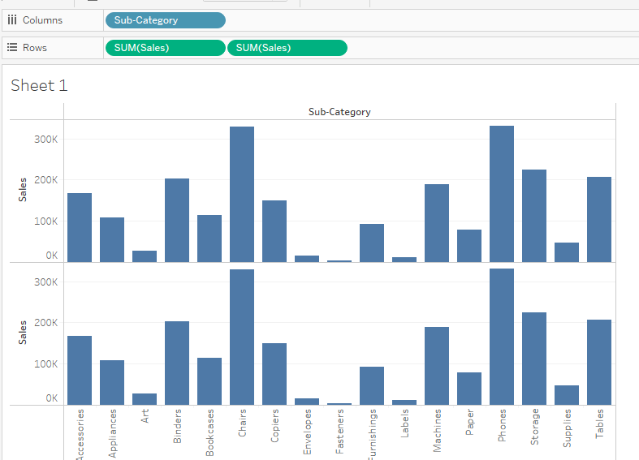

Goto to the Sales(2) for changing the plot type as line

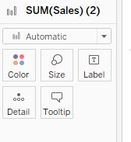

You will then know changes in the plots, observing the below visualization

Go to sales2 in the ROW click on the down arrow and select the Dual axis, you will get the below-mentioned visualization

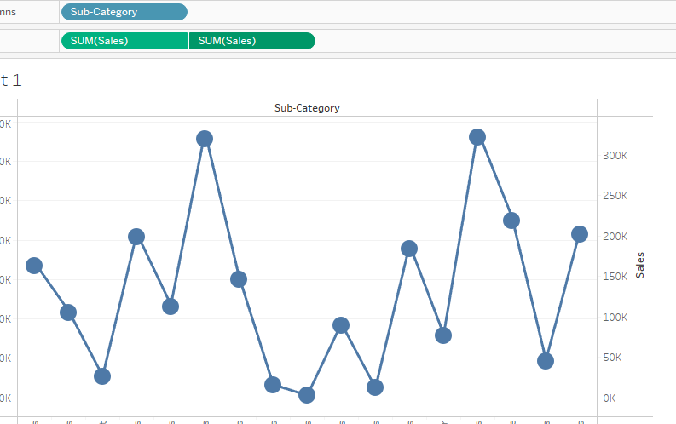

Afterwards select the sales -🡪 select the Bar chart you will notice the below view

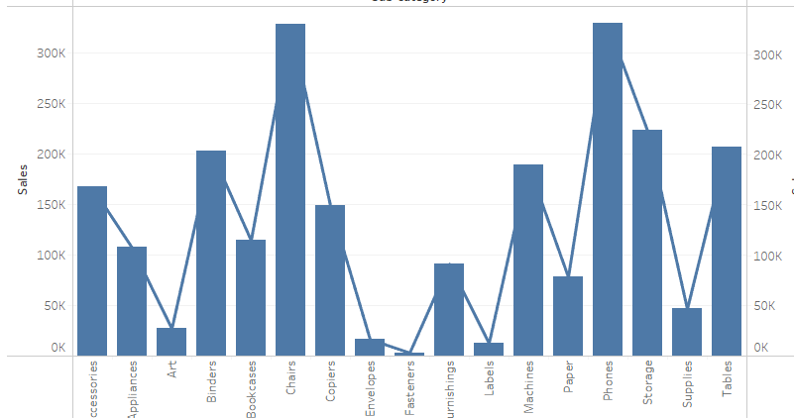

Afterwards go to the Colum: Sub category -> click the down arrow and select the **sort** option & select as field, select the check box as Descending you will notice the below view

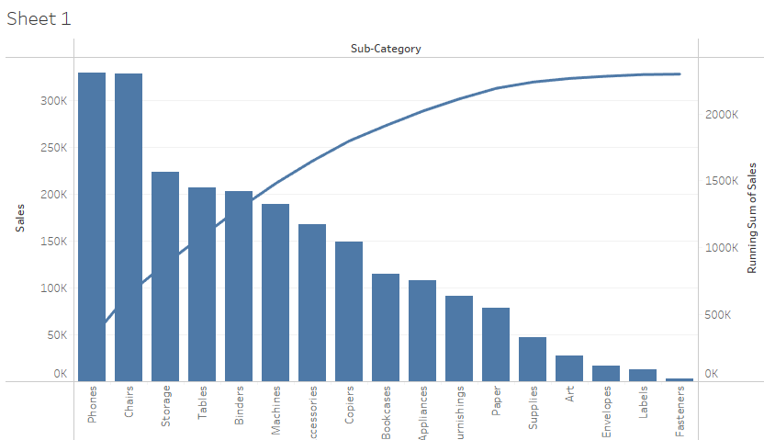

Here can apply Colours for the Visualization

